

An AI Approach to a World Domination Game

Edward James PasfieldBSc in Computer Science

17/04/2018

SCHOOL OF COMPUTING AND MATHEMATICS   
Keele University   
Keele   
Staffordshire   
ST5 5BG

# 1.0 Abstract

Lots of traditional board games such as chess, checkers, and even some more complicated ones such as RISK, have been converted to computer games over the past 20. This report will breakdown the methodology of how one would go about designing a simplistic zero-sum, where one only gains by taking, game through the use of prototyping, to create Global Conquest. A wold domination strategy game in co-operation with why each feature for this was implemented in its own way, explaining and giving examples of appropriate programming practices. Whilst also demonstrating how the iteration of this methodology along with a comprehensive set of technically thorough test allowed it to move forward in such an efficient manner.

The report will then go on to a discussion about whether the enemy, also known as the agent, should be developed through the use of heuristics or the use of artificial intelligence. Which will disassemble how these two complex intelligent agent designs perform and how appropriate they are based on the ease of implementation and feedback from possible users. The discussion finishes with a conclusion that the heuristic based approach will be more appropriate, mainly due to the pros and cons of both methods and their effectiveness in the context of Global Conquest. Finally, followed by a conclusion of the whole report and project which explains what did and did not get achieved, along with why. As well as comprehending future design possibilities, parallel to the possibilities of the agent’s way of working.

# 2.0 Acknowledgements

There are two people I would like to give some acknowledgement towards for this project and report. James Borg my project supervisor, was a great source of information and advice with how I should develop Global Conquest, his support along with Keele University has been very critical.

# Table of Contents

1.0 Abstract 2

2.0 Acknowledgements 3

Table of Contents 4

3.0 Introduction 5

4.0 Main aims and objectives 10

5.0 Methodology 11

5.1 Requirements Elicitation 13

5.1.1 Functional Requirements 14

5.1.2 Non-Functional Requirements 14

5.2First Prototype 15

5.2.1 Quick Design 15

5.2.2 Building Prototype 15

5.2.3 Customer Evaluation 16

5.3 Second Prototype 17

5.3.1 Quick Design 17

5.3.2 Building Prototype 18

5.3.3 Customer Evaluation 19

5.4 Third Prototype 20

5.4.1 Quick Design 20

5.4.2 Building Prototype 20

5.4.3 Customer Evaluation 22

6.0 Results 23

6.1 Test Cases – Unit Testing 23

6.2 User Testing Interviews 27

6.4 Product Evaluation 31

6.5 Introspection 31

7.0 Discussion 32

8.0 Conclusion 38

9.0 Bibliography 41

3.0 Introduction

This report explains the creation of Global Conquest, a game based on the board game RISK with an added basic artificial intelligence entity (agent) which acts as the ‘enemy’ for a user to compete against. The academic purpose of this is to look into how heuristics work and whether their implementation in a game makes the agent more engaging to play against. The problem first and foremost in creating a fully functional game; allowing a user to allocate troops to owned territories and to attack enemy controlled territories through easy mouse inputs, the two most basic user control concepts in a domination based game. The second challenge was getting the agent to follow sets of predefined rules (heuristics). The game was created to a high level of quality by developing it in a logical manner through the use of prototyping, a design methodology based on an iterative approach. This report follows up with a discussion on whether a fully artificial intelligence approach, through the use of Neural Networks and specifically Deep Reinforcement Learning, would produce a more competitive agent to play against as it might have a better understanding of the game.

The more practically applicable reason for this report is the programming layout set by actually creating the game with the highest level of quality possible. Some background knowledge to help with understanding the game is that to play you need to first allocate your initial 15 troops to territories, then done roll the dice for the ‘attack strength’ and the troops to be allocated next turn. The attack phase then begins during which one attacks by either clicking on competing territories or dragging from the territories to wherever your tactics suggest and repeat. This process is how the gameplay works until all the territories are owned by either the user, agent or if the turn counter hits 30 causing the game to end with either a win or a loss. There are many variations of RISK on PC format e.g. Lux Deluxe and other more complicated domination based games for example Sid Miers Civilization IV. Global Conquest however is relatively basic and is quite similar to Lux in principal just without the small animations, it carries out the troop allocation and attack phases.

(Cs.cmu.edu, 2018) describes heuristics as being responsible for considering all possible moves the agent can currently make and determine which action has the most benefits. “A good example of this in the context of my game would be if the agent looked for the highest ratio between its troops and the users, and to fight for the one with the best odds of winning while taking into account the benefits of the territory.” (Pasfield, 2018). It has been suggested that most of the state of the art intelligent agents for playing games called zero-sum games are best when they search through a *tree* for the optimal outcome (Ozcan, 2018). Zero-sum is also defined in this paper as a game type that indicates that a participant can only gain at the expense of another; and Global Conquest follows this rule. The paper written by Ozcan is titled ‘A Simple Intelligent Agent for Playing Abalone Game: ABLA’ although it introduces the topic of the intelligent agent very lightly, it becomes a more complex and informative study and provides some perfect examples of intelligent agents being applied. A fair amount of flair along with a gentle conclusion about how their agent ABLA was in fact beating humans at the game Abalone, combined with the trusted non-biased opinions and facts of an academic rather than commercial paper, led to the conclusion to develop the Global Conquest agent in the same way. This is a strong suggestion for anyone trying to understand the idea of implementing an intelligent agent, into a relatively basic game.

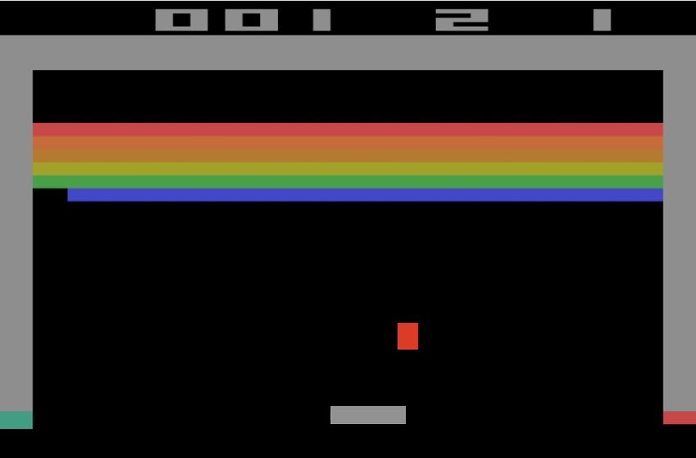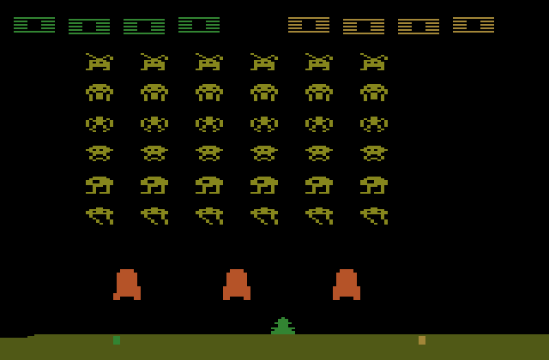The breakdown of whether Artificial Intelligence (AI) could or should be used for Global Conquest is up for debate; there are groups of teams such as DeepMind which have been developing AI that learns to play simple games, such as Space Invaders and Breakout etc.

*Figure 1.*

To do this they use Reinforcement Learning (RL), a teaching technique based on rewards and punishments, to further evaluate if it does something that benefits itself and let it know, so it will keep going in the same direction. If however, it does something wrong it will then influence it to not do something similar again. This along with deep learning is a more proficient approach to estimating environments, which is what makes DeepMind so effective (Mnih, 2018), to the extent that its network can teach itself to play multiple different games at the same time. They call this approach Deep Reinforcement Learning (DRL). This is the approach which was attempted for Global Conquest, as it has shown to be effective for relatively basic games (those that are easy to learn and hard to master, with a good learning curve). “The most successful approaches are trained directly from the raw inputs, using lightweight updates based on stochastic gradient descent.” (Mnih, 2018). Mnih, is expressing that DRL still uses Deep Learning which has multiple hidden layers for a much more dynamic neural network than a simple neural network illustrated in figure 3, should be trained directly from the raw inputs.

*Figure 2.*

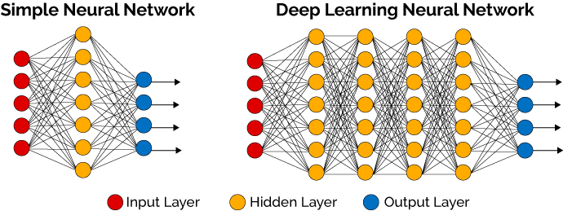

*Figure 3.*

It is stated so strongly here, due to the trustworthiness of Mnih’s work. To be able to feed this network raw inputs, some work may have to be done around the agent even further, as to collect and implement the appropriate type. The reinforcement part of DRL will apply a similar approach to Q-learning in the sense that it will operate with a function value, a more mathematically enforced way of learning with numerical rewards and punishments, attempting to find its way to an end goal. Mnih also states “stochasticity in the dice rolls helps explore the state space and also makes the value function particularly smooth” (Mnih, 2018), a very apt quote that will hopefully reflect on the way it is introduced into Global Conquest, as dice rolls are a big part of the maths behind the game play. The paper written by Minh, previously referred to a few times, is called ‘Playing with Deep Reinforcement Learning’; this paper was very useful when understanding the steps one should take to enable deep reinforcement learning to be implemented. It succinctly depicts the different aspect of DRL, in addition to being a well-structured and clarifying read. The structure introduces the user to a well informed source of information through a well written introduction and background. Later going in depth into the working of DRL, which was the essence of the paper, backed up with experiments which conclude that even though the network isn’t as good as human experts it is better than other networks of similar types and can learn to a proficient standard at a multitude of games. One has to keep in mind potential biases of those who carried out the experiments and wrote the paper though – it is in the best interests of those at DeepMind to have DRL become more trusted as a method. While this is a possible reason for skewed results or opinions which would certainly influence the paper, it is hard to tell whether this is deliberate or not.

# 4.0 Main aims and objectives

1. The creation of the UI (user interface) including replicating the world map.
2. Make a smooth well designed game.
3. All Object-Oriented Programming.
4. Make the agent intelligent, adaptive and competitive.
5. Carry out interviews to get feedback for requirements elicitation.
6. Make Global Conquest a quality product.
7. Train an artificially intelligent agent to play through the use of deep reinforcement learning.
8. Clear documentation through the prototyping methodology during the development process clarifying what was appropriate or not, and why.
9. Carry out test cases throughout development to determine what was successful and what was not, to enable rework as needed and subsequent retest.

These aims and objectives were created to be succinct, brief relatively interrelated and an even mix between what to be achieved and how to achieve it. For instance number 6 (Make Global Conquest a quality product) is a “what to achieve” whereas number 9 (Carry out test cases...) is a “How to”.

# 5.0 Methodology

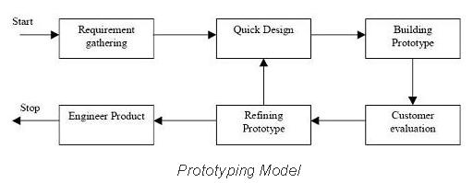The system design for Global Conquest was done through the methodological process called prototyping a very dynamic systems development method (SDM). This follows the (Prototyping Model, 2018) shown in figure 4. Which is known for its faster iterations and for allowing lots of tweaks depending on what the users testing the program suggests along with the opinions of the developer. It is mainly used for creating a quick model to show a possible customer, and was beneficial in this case. Firstly, because of the creativeness of the project changes were not big deals during development of Global Conquest as the next iteration of the model could be shown to users in the next customer evaluation phase. Secondly, because it meant there was less time spent on the development of the games usability and more on how it actually works, this increased the quality of the background code. Another main advantage of this model is that errors are detected earlier and missing functionality is identified more easily, which means a functioning program will be up and running more quickly. A couple of the major disadvantages of this model however are it leads to lots of repairing, which in turn can increase the complexity of the system (Anon, 2018) if not identified and correctly addressed.

*Figure 4.*

The programming language selected for this project was Processing. Processing is a flexible sketchbook for software and a language based on Java for coding within the visual arts context (Processing.org, 2018). It is a simple enough language to get to grips with and with an easy use of visual arts this enabled focus to be on the way the code worked rather than fussing around with all the UI parts, making the game aesthetically pleasing.

Javas simplified syntax and good portability meant there were many opportunities for editing code in any circumstance. When actually programming Global Conquest a breakdown of all the possible objects was a strong and decisive start point. It clearly identified the areas of code for encapsulating the objects of Territory, User and Agent (Fig 5.) a heavy debate was whether Troop should be an object as well. 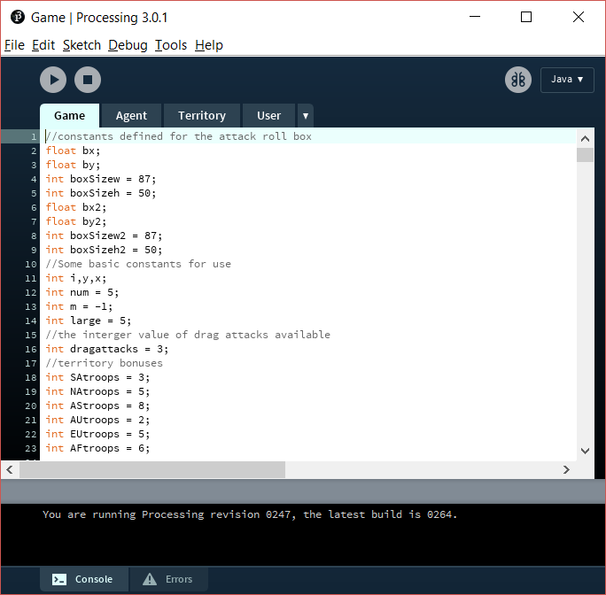

*Figure 5.*

## 5.1 Requirements Elicitation

The purpose of requirements elicitation is to identify the risks, needs and assumptions associated (Masters, 2018). Gathering requirements over the years has differed massively in terms of game design, with the use of user testing and over the years this has become a group collaboration between the stakeholders, developers and users (Fidas, 2018). Originally the requirements for Global Conquest were gathered through the use of brainstorming, prototyping and interviews - three well known techniques that are more business based but which were tailored to the context of the game. Brainstorming was done throughout development, and was a constant point of referral but as there was only one developer he brainstormed with the project supervisor (James Borg) rather than other co-developers. Initially they met weekly sharing thoughts and getting another point of view to feed off, then when the games approach was more established the meetings moved out to fortnightly. Prototyping allows a much better understanding of the end product as the visual representation can be provided from paper examples to interactive gameplay, with game play tested using test cases which is an effective method of systematically testing a system to make sure it is functioning to its true potential. After each iteration of the prototype, the requirements would evolve slightly based on the stakeholders input and from input gathered during interviewing. Finally, but not least important, were the interviews on outsiders opinions of the game which produced a lot of great feedback on whether it was adequate along with possible requirements that hadn’t previously been considered – it is a really effective requirements elicitation technique.

### 5.1.1 Functional Requirements

* Allow user to assign troops
* Allow user to roll dice
* Allow user to attack internally or externally
* Allow agent to assign troops
* Allow agent to roll dice
* Allow agent to attack internally or externally
* Agent heuristics so there are easy/medium/hard modes
* Artificially intelligent agent to play against
* Assign Territory bonuses
* Enforce maximum troop capacities
* Calculate a win or a loss

### 5.1.2 Non-Functional Requirements

* Computer good enough to run processing (correct platform)
* Mouse/track pad
* Frame Rate
* Required resources
* To be Secure

## 5.2 First Prototype

### 5.2.1 Quick Design

This was the first iteration of the prototyping methodology however, the requirement gathering for the beginning of the prototyping method shown in figure 1 was the requirements elicitation. The quick design stage in this instance was in fact the attempted implementation of new requirements to try and complete in the following prototype. The ones chosen in the first iteration were mainly to create a UI of the world map, while following object-oriented programming (OOP) techniques.

### 5.2.2 Building Prototype

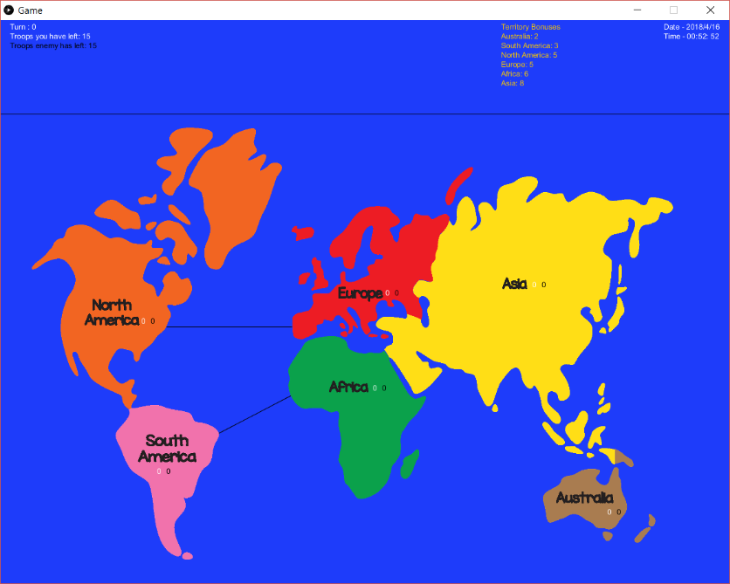After the three objects were set in stone, a basic enough UI was next on the agenda as that would enable users to reveal if the implementation was functioning correctly. This was accomplished by breaking down an image of a world map (World Map – Continents, 2018) combined with the use of paint.net (image editing software) which allowed the cropping of all individual continents into separate images with a translucent background. This enabled the creation of the map figure 6.

*Figure 6.*

A prolonged period of time was spent trying to get Processing to listen to detect when the mouse was over each image, however this proved problematic and there was no way for the listening to be implemented. Instead boxes defined in Processing as a 2D primitive allowed boxes to be created under the images which could then be individually listened to by the program (Figure 7.) found in appendix B.

//RUN IF MOUSE CLICKED

*Figure 7.*

void mouseClicked(){

if(count < 15 || tArray[0].troopnum > 0 || (tArray[0].troopnum == 0 && tArray[0].atroopnum == 0)){

if (mouseX >= tArray[0].x && mouseX <= tArray[0].x+(SAy+20) &&

mouseY >= tArray[0].y && mouseY <= (tArray[0].y+SAx-200) ) {

//check to see if the mouse clicks SOUTH AMERICA

Once these had been correctly positioned this meant that the territories had a way of being interacted with, a primary concept of Global Conquest. After this interactive map had been made available, the actual programming and maths behind the game had to be completed. The draw method in Processing acts as a constant for loop updating the UI which is advantageous because of the listening that is constantly occurring for events. An event processing language, allows a dynamic reaction to things such as mouse clicks, key presses or any interactions.

### 5.2.3 Customer Evaluation

For the first iteration of the model, as it was too preliminary to get any users involved the project supervisor (James Borg) carried out the evaluation. He gave his opinions on the map/UI as well as his approval of the original system design, so the developer moved on to refining the prototype which was to determine what step requirements were next to be implemented.

## 5.3 Second Prototype

### 5.3.1 Quick Design

The next interactions were how the user plays, clicking on territories to allocate troops, rolling attack, troop reserves and attacking enemy troops internally or externally. Actions such as these could only be implemented once the program had been split up into all the separate objects needed, as these interactions had to occur in an encapsulated, reusable manner a good practice when programming the basics of object-oriented programming (OOP). The only negative is that when trying to implement OOP a class had to be created to allow for functions to be implemented between that and the main running code. These classes had to be developed so that the ‘objects’((Stefik, 2018) defines objects as “entities that combine the properties of procedures and data since they perform computations and save local state”) could be uncomplicated and have attributes that are very easily called upon/sent messages such as new troop numbers.

Traversing back to the actions the object defined user will be making, attacking internal/external and troop allocation. This was made easier by the OOP mainly because it was more straightforward to put the code into the correct areas and have reactions based on events, such as clicking a territory, as everything was modularised.

### 5.3.2 Building Prototype

Once a click had occurred on a specific territory, for example Africa, and depending on the state of the game being either in the attack phase or allocation (flagged by simple boolean variables) the attack calculation would take place or, a simple allocation would occur (Figure 8). This would in turn send a message to the territory array object ‘Africa’ and update its troop numbers and/or ownership depending on whether the event had left it without agent troop numbers.

if(click == 1){

tclicked = true;

*Figure 8.*

uattacks = uattacks -1;

pressedSA = true;

//Internal territory attack calculation

if(tArray[0].atroopnum < uArray[0].uaroll1){

tArray[0].troopnum = tArray[0].troopnum - tArray[0].atroopnum;

}

else{

tArray[0].troopnum = tArray[0].troopnum - uArray[0].uaroll1;

}

//Dont allow the user troop number to drop below 0

if(tArray[0].troopnum < 0 ){

tArray[0].troopnum = 0;

}

tArray[0].atroopnum = tArray[0].atroopnum - uArray[0].uaroll1;

//Dont allow the agent troop number to drop below 0

if(tArray[0].atroopnum < 0 ){

tArray[0].atroopnum = 0;

}

}

}

else{

//if click occurs on a territory and there are user troops in the reserve then...

//add one to the territory and minus one from the reserve

tArray[0].troopnum = tArray[0].troopnum + 1;

utn = utn -1;

}

A second action is external attacks, these are caused by dragging the mouse from one territory to another, to attack if the enemy has troops in the territory or to transfer forces to a territory already owned. Similar is the internal attacks implementation, where the system listens for a release of the mouse over a territory and checks to see if it was pressed down over a connecting territory e.g. Australia/Asia this is shown in figure 9.

/////////////////////////////// Release on AUstralia

*Figure 9.*

// if mouse released on Australia

if (mouseX > tArray[3].x && mouseX < tArray[3].x+(200) &&

mouseY > tArray[3].y && mouseY < (tArray[3].y + 150 )) {

releaseAU = true;

//if during attack phase and there are drag attacks left and Asia was pressed

if(releaseAU == true && click == 1 && pressedAS == true && dragattacks > 0 && tArray[2].atroopnum == 0){

///transfer of troops

// Drag attack calculations depending on whether the agent has no troops in the territory...

// and whether the agent troops or the user troops are smaller than the user rolled attack

If this occurs then the system does the maths behind the attack or the transfer. For an attack from Asia to Australia, the system calculates agent troops in Australia minus the attack strength of the user. For a transfer, the system subtracts the attack strength from the user troops in Asia and adds them to the user troops in Australia. Also, the system will not allow either an attack or a transfer that would drop anything below 0 as you cannot have negative troops.

### 5.3.3 Customer Evaluation

During this second prototype iteration test cases were introduced as the approach to customer evaluation, which was achieved by the developer carrying out a systematic comb through of the code, testing all he could and documenting what failed its tests. The failures helped the developer identify opportunities to refine the code and also the need for some new code to address unrealised requirements.

## 5.4 Third Prototype

### 5.4.1 Quick Design

A realisation that there would need to be rewards for owning a territory. It was determined its value should depend on the combination of two factors – the size of a territory combined with the number of connections the territory has to other territories. A second realisation made during initial testing of this troop bonus was that the troop numbers in some territories went- into the hundreds in only 5-6 turns. This was not acceptable as it would make this wall of troops impenetrable to an opponent whose maximum attack strength was limited to 6 by the rules.

### 5.4.2 Building Prototype

To address the above realisations, the need for a reward led to a ‘troop bonus’ and a maximum troop capacity (Figures 10 & 11.) were added to the object Territory to constrain numbers of troops per territory thereby making winning or losing realistically achievable, provided the dice rolls are lucky enough.

*Figure 11.*

*Figure 10.*

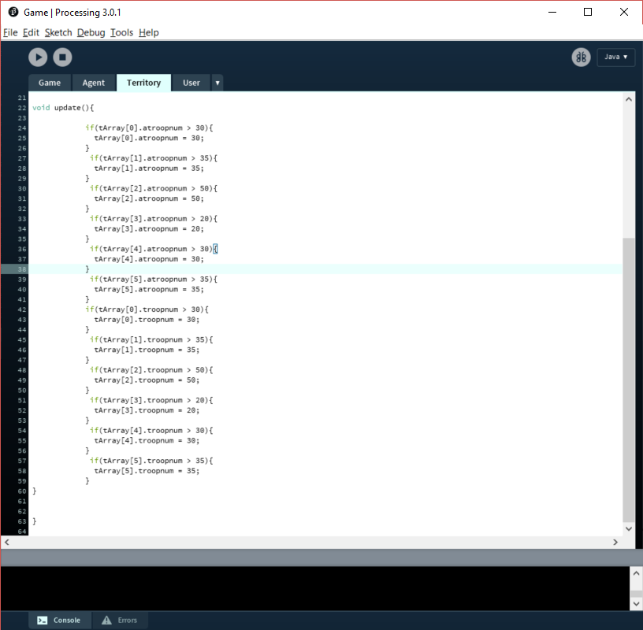 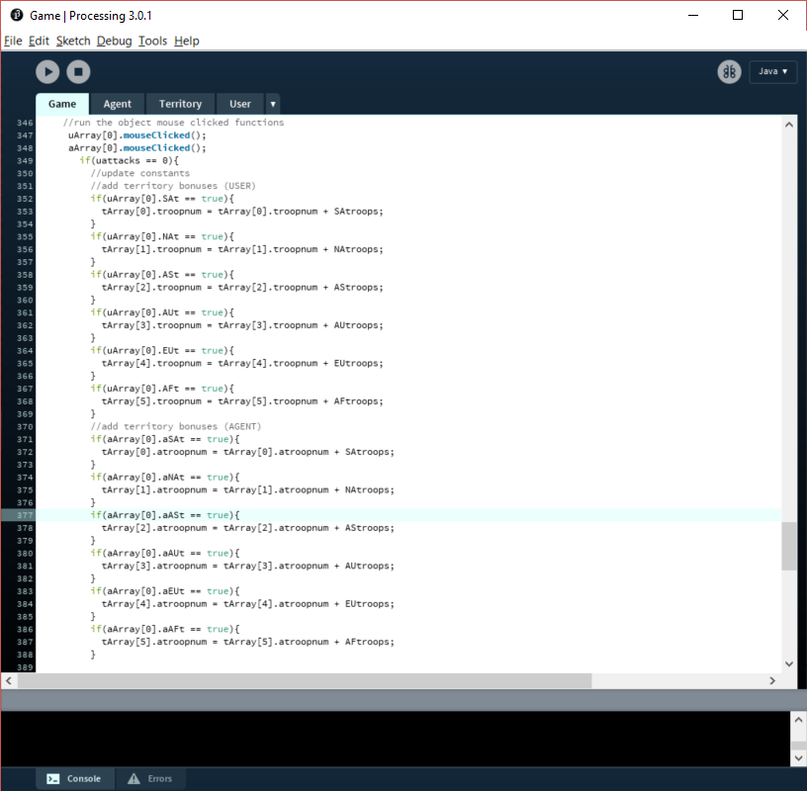

Another one of the objects in question for Global Conquest is the agent that is acting as the enemy. The aim for this agent was for it to be able to make logical decisions to help it towards winning. When programming this a great deal of thought had to go into data acquisition for the use of decision making. A few different formats of data were used; Booleans, Arrays, Integer Lists etc. However a starting point was to make the agent randomly use the data for attacks, which meant having to effectively implement the random pre-defined function along with the Booleans used for flagging when a territory was owned, to find out where to be attacking, and an integer list to store the non-owned territories to randomly choose from just for troop allocation the code for which is shown in figure 12. A complicated but necessary route of action.

*Figure 12.*

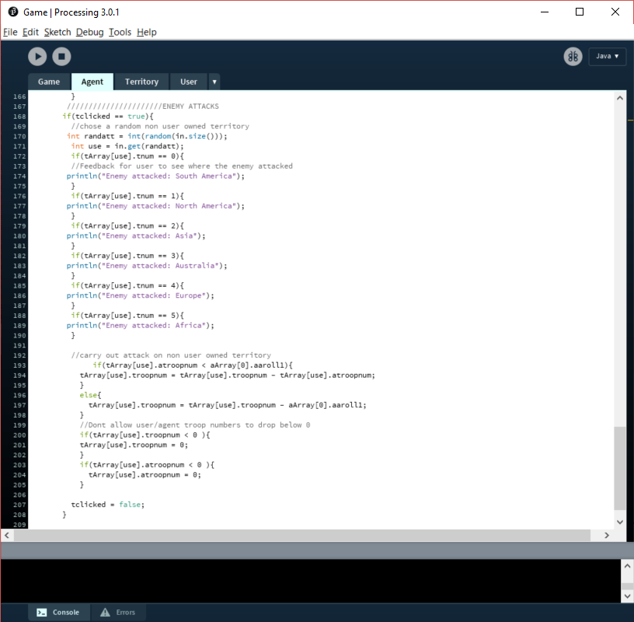

Once this agent was created and could randomly attack, the data it was being handed had to be used intelligently to inhibit the ‘logical’ decisions that it had to make. An agent in itself is situated in an environment and is capable of autonomous action in order to meet its objectives (Agent Technology, 2018). There was a long list of rules that were implemented in the agent object, a large proportion of which ended up using very random ways of attacking and allocating. However, this would be easily developed in the future. To make the task of enabling the agent to make logical decisions a need to provide it with an end goal, or goals to aim for became apparent. This in theory was possible with the use of some variables such as territory capacity and troop bonuses as goals. They would have to be put on a scale of benefits and the agent would have to make its decisions based on how large the benefit is, which in theory is relatively simple but in practice less so.

### 5.4.3 Customer Evaluation

The customer evaluation for the third prototype was a post-game interview, made to gather information about whether users liked or disliked different aspects about the game and background information to see if they usually enjoyed games of this nature. Targeting possible users in a range of 18-21 year old university students is a strong way of finding a wide range of opinions, ideas and out of the box possibilities. This led to refining the prototype to a point of uncertainty over whether development should aim towards an intelligent agent or train an artificial intelligence to act as the enemy.

6.0 Results

## 6.1 Test Cases – Unit Testing

These test cases test many of the technical aspects of Global Conquest code. Each test case has its own test case ID which have been split up into general test cases (TC00), user test cases (UTC00), agent test cases (ATC00) and territory test cases (TTC00). When creating figure 13 the code was systematically combed through testing at all the major implementations, which turned out to be mostly requirements or aims and objectives.

|  |  |  |  |  |
| --- | --- | --- | --- | --- |
| **Test Case ID** | **Test Scenario** | **Test Steps**  *Figure 13.* | **Expected Results** | **Actual Results** |
| TC01 | Check Initial user Troop allocation Works | 1.Click on South America  2. Click on North America  3. Click on Asia  4. Click on Europe  5. Click on Australia  6. Click on Africa | 1 troop allocated to user troop number in each territory | 1 troop allocated to user troop number in each territory.  **Pass** |
| TC02 | Check Initial agent Troop allocation Works | 1.Allocate all initial agent troops | 15 randomly allocated agent troops | 15 randomly allocated agent troops  **Pass** |
| TC03 | Check roll attack box appears when user troop reserve hits 0 | 1.Allocate troops until user troop reserve hits 0 | Roll attack box appears | Roll attack box appears  **Pass** |
| TC04 | Mouse hover over roll attack box changes the tint of the box | 1.Allocate troops until roll attack box appears  2. Move mouse over the roll attack box | The box colour gets darker | The box colour gets darker  **Pass** |
| TC05 | Once the roll attack box has been clicked randomly roll attack strengths and troop reserves for next turn (USER). | 1.Allocate troops until roll attack box appears  2. Move mouse over the roll attack box  3.Click the roll attack box | User Attack Strength = 1-6  User Troop Reserve = 1-12 | User Attack Strength = 1 User Troop Reserve = 2  **Pass** |
| TC06 | Once the roll attack box has been clicked randomly roll attack strengths and troop reserves for next turn (USER). | 1.Allocate troops until roll attack box appears  2. Move mouse over the roll attack box  3.Click the roll attack box | User Troop Reserve = 6-12 | User Troop Reserve = 8  **Pass** |
| TC07 | Once the roll attack box has been clicked randomly roll attack strengths and troop reserves for next turn (AGENT). | 1.Allocate troops until roll attack box appears  2. Move mouse over the roll attack box  3.Click the roll attack box | Agent Attack Strength = 1-6  Agent Troop Reserve = 1-12 | User Attack Strength = 3 User Troop Reserve = 10  **Pass** |
| TC08 | Once the second internal territory attack has been used, end attack phase and update troops (USER) | 1.Allocate troops until roll attack box appears  2.click the roll attack box  3. click on territory with user troops twice | The user troops to be allocated next turn becomes the new troop reserve | The user troops to be allocated next turn becomes the new troop reserve  **Pass** |
| TC09 | Once the second internal territory attack has been used, end attack phase and update troops (AGENT) | 1.Allocate troops until roll attack box appears  2.click the roll attack box  3. click on territory with user troops twice | The agent troops to be allocated next turn becomes the new troop reserve | The agent troops to be allocated next turn becomes the new troop reserve  **Pass** |
| TC10 | Test the enter button can only be pressed once the attacks have been rolled | 1.Allocate troops until roll attack box appears  2.click the roll attack box  3. click on territory with user troops twice  4.Allocate all of the user troops  5.Press Enter | Nothing happens update troops | Nothing happens  **Pass** |
| TC11 | Test the enter button can skip the attacks | 1.Allocate troops until roll attack box appears  2.click the roll attack box  3. click on territory with user troops twice  4.Allocate all of the user troops  5.Roll attacks  6.Press Enter | Troop reserves Update and attack phase ends | Troop reserves Update and attack phase ends  **Pass** |
| TC12 | You win! Appears when the user owns all the territories | 1.Allocate troops until roll attack box appears  2.click the roll attack box  3.Use drag attacks tactfully  4.click on territory with user troops twice  5.Allocate all of the user troops  6.Roll attacks  7.Repeat until win | You Win! Appeared | You Win!  Appeared  **Pass** |
| TC13 | All the territory bonuses are added (USER) | 1.Allocate troops until roll attack box appears  2.click the roll attack box  3. click on territory with user troops twice | Territories owned by user increase by correct territory bonus | Territories owned by user increase by correct territory bonus  **Pass** |
| TC14 | All the territory bonuses are added (AGENT) | 1.Allocate troops until roll attack box appears  2.click the roll attack box  3. click on territory with user troops twice | Territories owned by agent increase by correct territory bonus | Territories owned by agent increase by correct territory bonus  **Pass** |
| TC15 | The Agent Can Win | 1.Allocate troops to Australia until roll attack box appears  2.click the roll attack box  3.Skip attack phase  4.Allocate all of the user troops to Australia  5.Repeat until Agent Wins | You Lose! appears | The game didn’t end  **Fail** |
| UTC01 | Internal territory attack, click on a territory with both user troops and agent troops in it | 1.Allocate troops until roll attack box appears  2.click the roll attack box  3. click on territory with both user troops and agent troops present | Took away the user attack strength from both user troops and agent | Took away the user attack strength from both user troops and agent  **Pass** |
| UTC02 | Internal territory attack, click on a territory with both user troops and agent troops in it | 1.Allocate troops until roll attack box appears  2.click the roll attack box  3. click on territory with both user troops and agent troops present, but where agent troops < user attack strength | Took away the user attack strength from both user troops and agent but didn’t go below 0 | Took away the user attack strength from both user troops and agent but didn’t go below 0  **Pass** |
| UTC03 | Check updated user Troop allocation Works | 1.Allocate troops until roll attack box appears  2.click the roll attack box  3. click on territory with user troops twice  4.Click on all territories with user troops present | 1 troop is added to each of the territories with user troops present | 1 troop is added to each of the territories with user troops present  **Pass** |
| UTC04 | Agent randomly clears out user troops | 1.Allocate troops until roll attack box appears  2.click the roll attack box  3. Drag from a user owned territory  4.Look for a random territory with user troops present to lose the agent attack strength in troops | Random territory with user troops present reduces by the same as the agent attack strength | A normal drag attack occurs, nothing seems to change  **fail** |
| ATC01 | Check updated agent Troop allocation Works, where it can only allocate to territories with agent troops in | 1.Allocate troops until roll attack box appears  2.click the roll attack box  3. click on territory with user troops twice  4.Use all of the user troops | A random troop is added to territories with agent troops present | A random troop is added to territories with agent troops present  **Pass** |
| ATC02 | Test the agent can allocate troops without a user input once the user has run out | 1.Allocate troops until roll attack box appears  2.click the roll attack box  3. click on territory with user troops twice  4.Use all of the user troops | The remaining agent troops are randomly allocated to territories with agent troops present | The remaining agent troops are randomly allocated to territories with agent troops present  **Pass** |
| TTC01 | The Territory maximums work | 1.Allocate troops until roll attack box appears  2.click the roll attack box  3.Use drag attacks tactfully  4.click on territory with user troops twice  5.Allocate all of the user troops  6.Roll attacks  7.Repeat until all territories are stuck at maximums troop capacity(either user or agent) | All territories stuck at maximums | All territories stuck at maximums  **Pass** |

## 6.2 User Testing Interviews

This is an example of the interview, relatively short but allows the person being interviewed to give the information required to find new requirements. The vagueness in some of the questions makes the person in this case Sam Longstaff to think outside the box and realise that a connection between Asia and North America might make for a more interesting competition for the territory. As shown in figure 14. These were used more for refining the prototype rather than testing the system.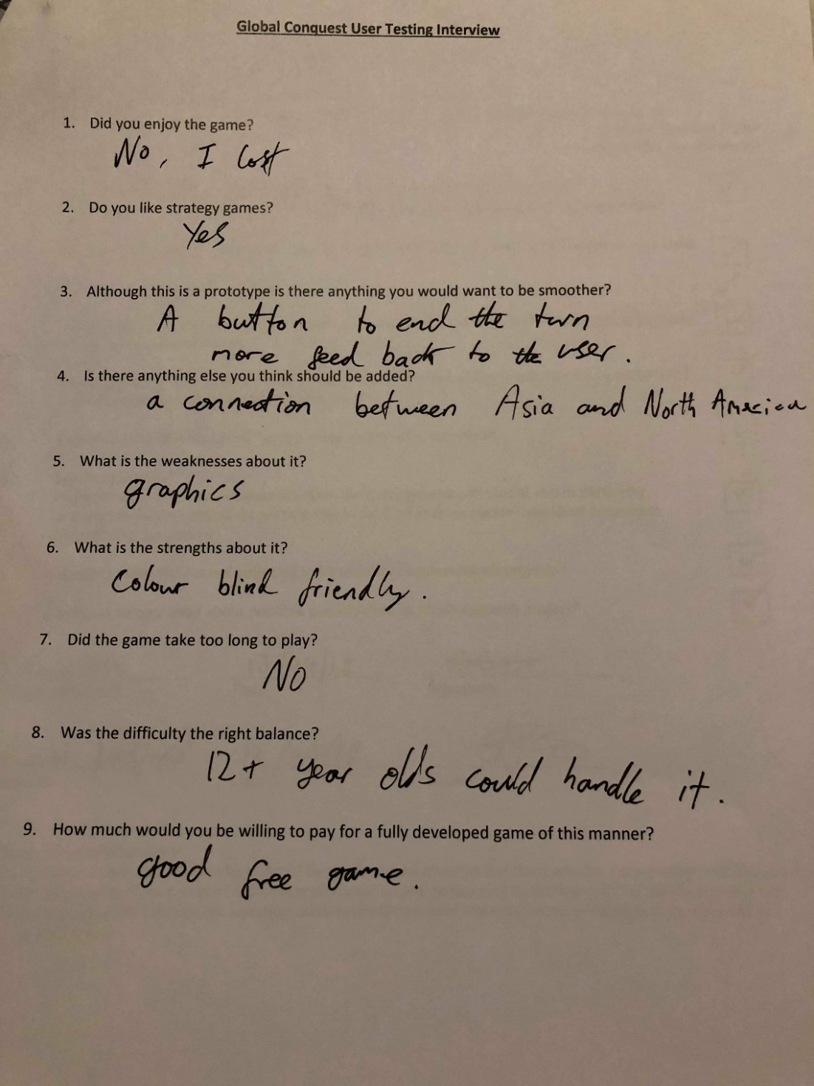

*Figure 14.*

There were lots of interesting points raised in the interviewing process, below are the ones which will positively contribute to the refining of the prototype. Especially as in figure 14, the tester lost the game which made him think about what could have helped him win, being a connection between Asia and North America. The strong competitive nature of problem solving is what kept the user interested, competitive problem solving is the primary way humans train themselves to think. (Burgen, 2013)

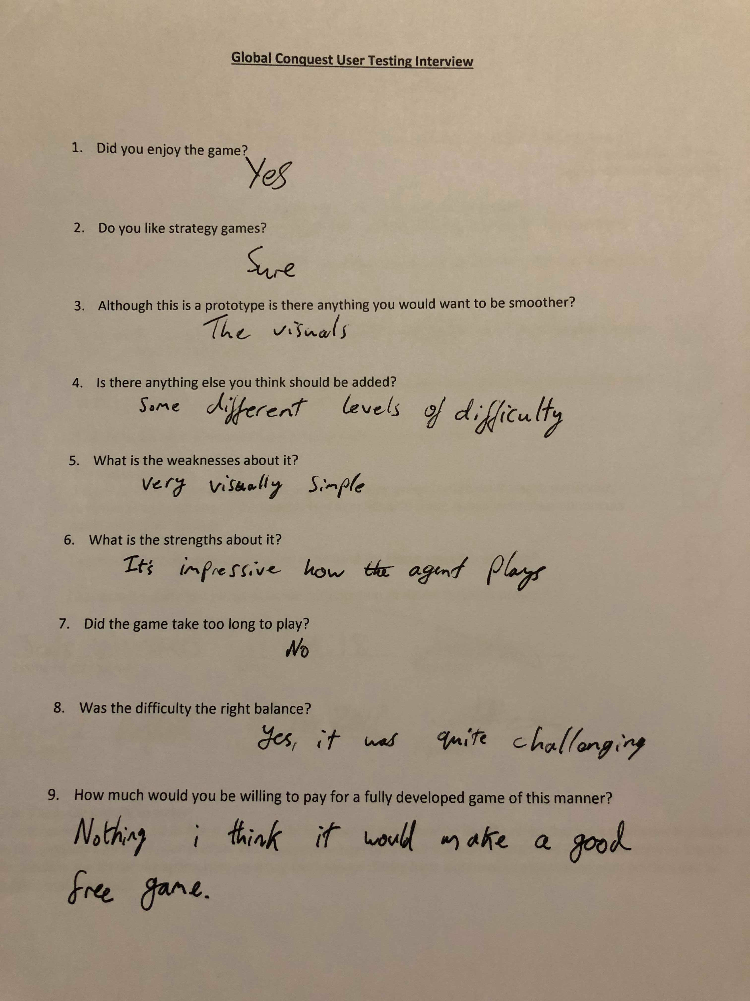

*Figure 15.*

Figure 15 is useful because it allows for gameplay at many different skill levels. 85% of people who contributed to a poll on gamespot agreed, this population group for a poll will be people who also enjoy games. Making then input much more topical. (Anon, 2018).

*Figure 16.*

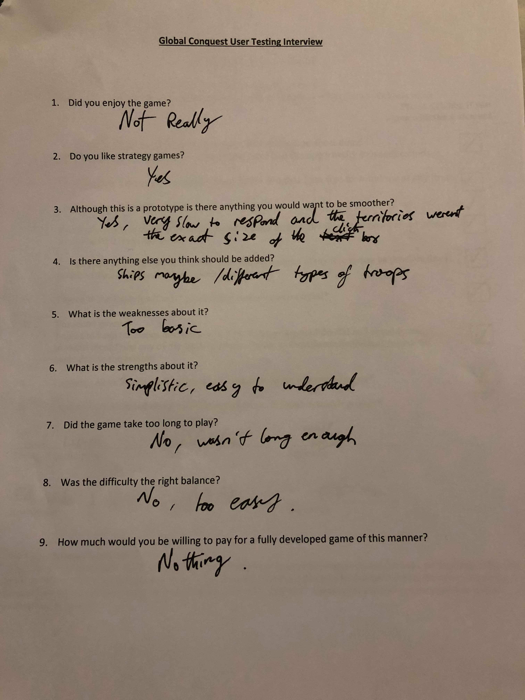

Figure 16 is interesting as a possible idea for making the game attacks more diverse a certain way of keep the player more engrossed.

*Figure 17.*

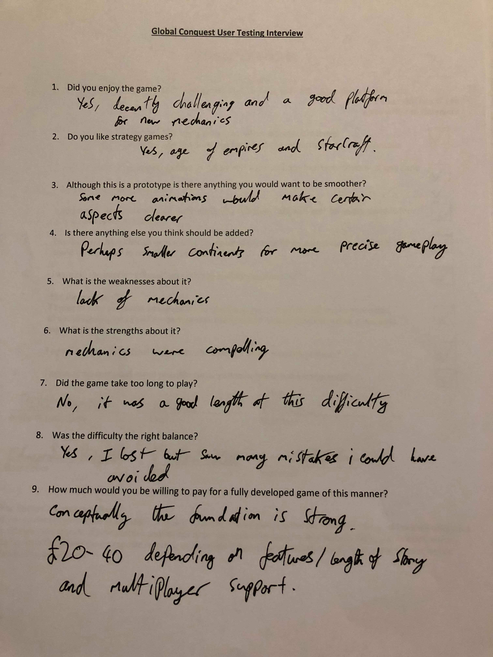

The end of this interview shown in figure 17 was informative, it let the developer know that even though the agent was random at this point it 30 turns was a good game length, and the randomness wasn’t good enough because the second time round the user would of avoided the mistakes made. Along with a compliment in quesiton 9, stating their opinion that the concept is strong.

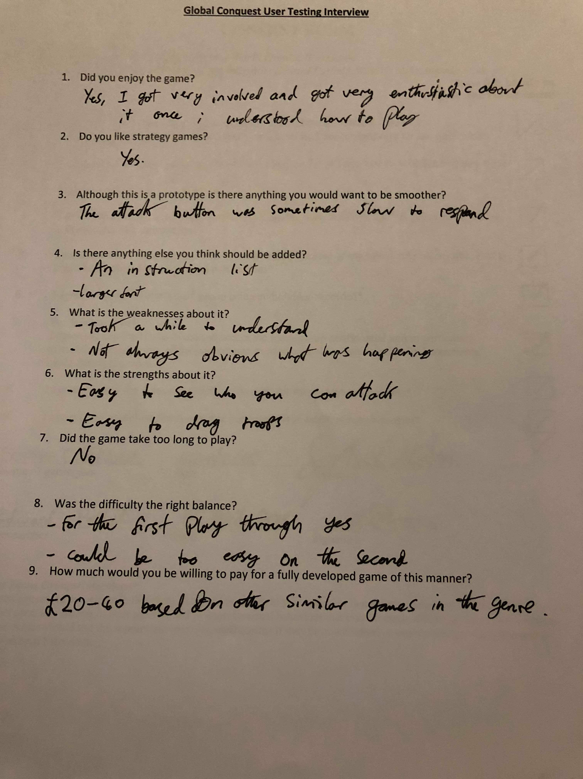

*Figure 18.*

Figure 18 and Figure 19 agree that some sort of move prompt/rules would be complementary to have on screen the help the usablility.

*Figure 19.*

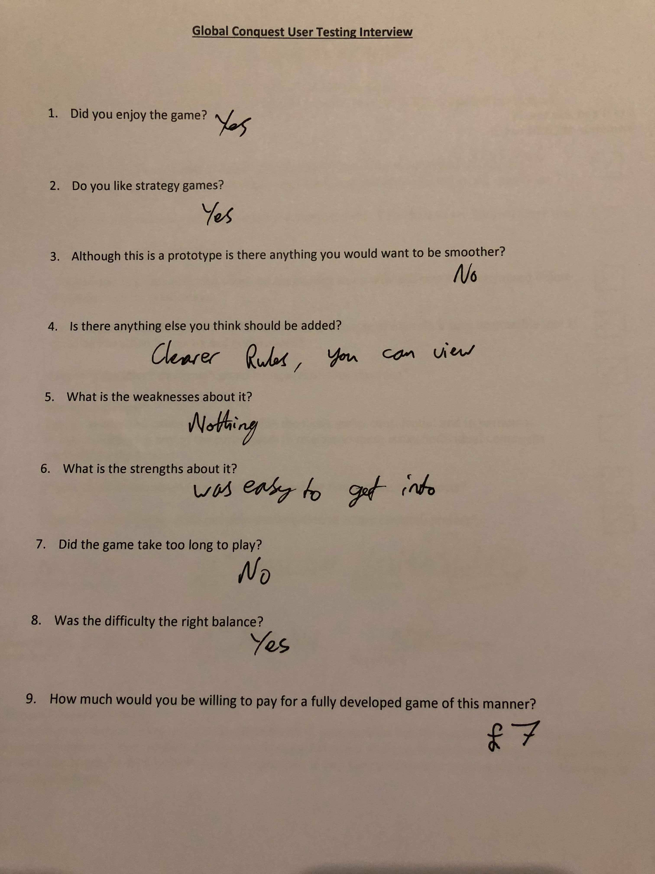

*Figure 20.*

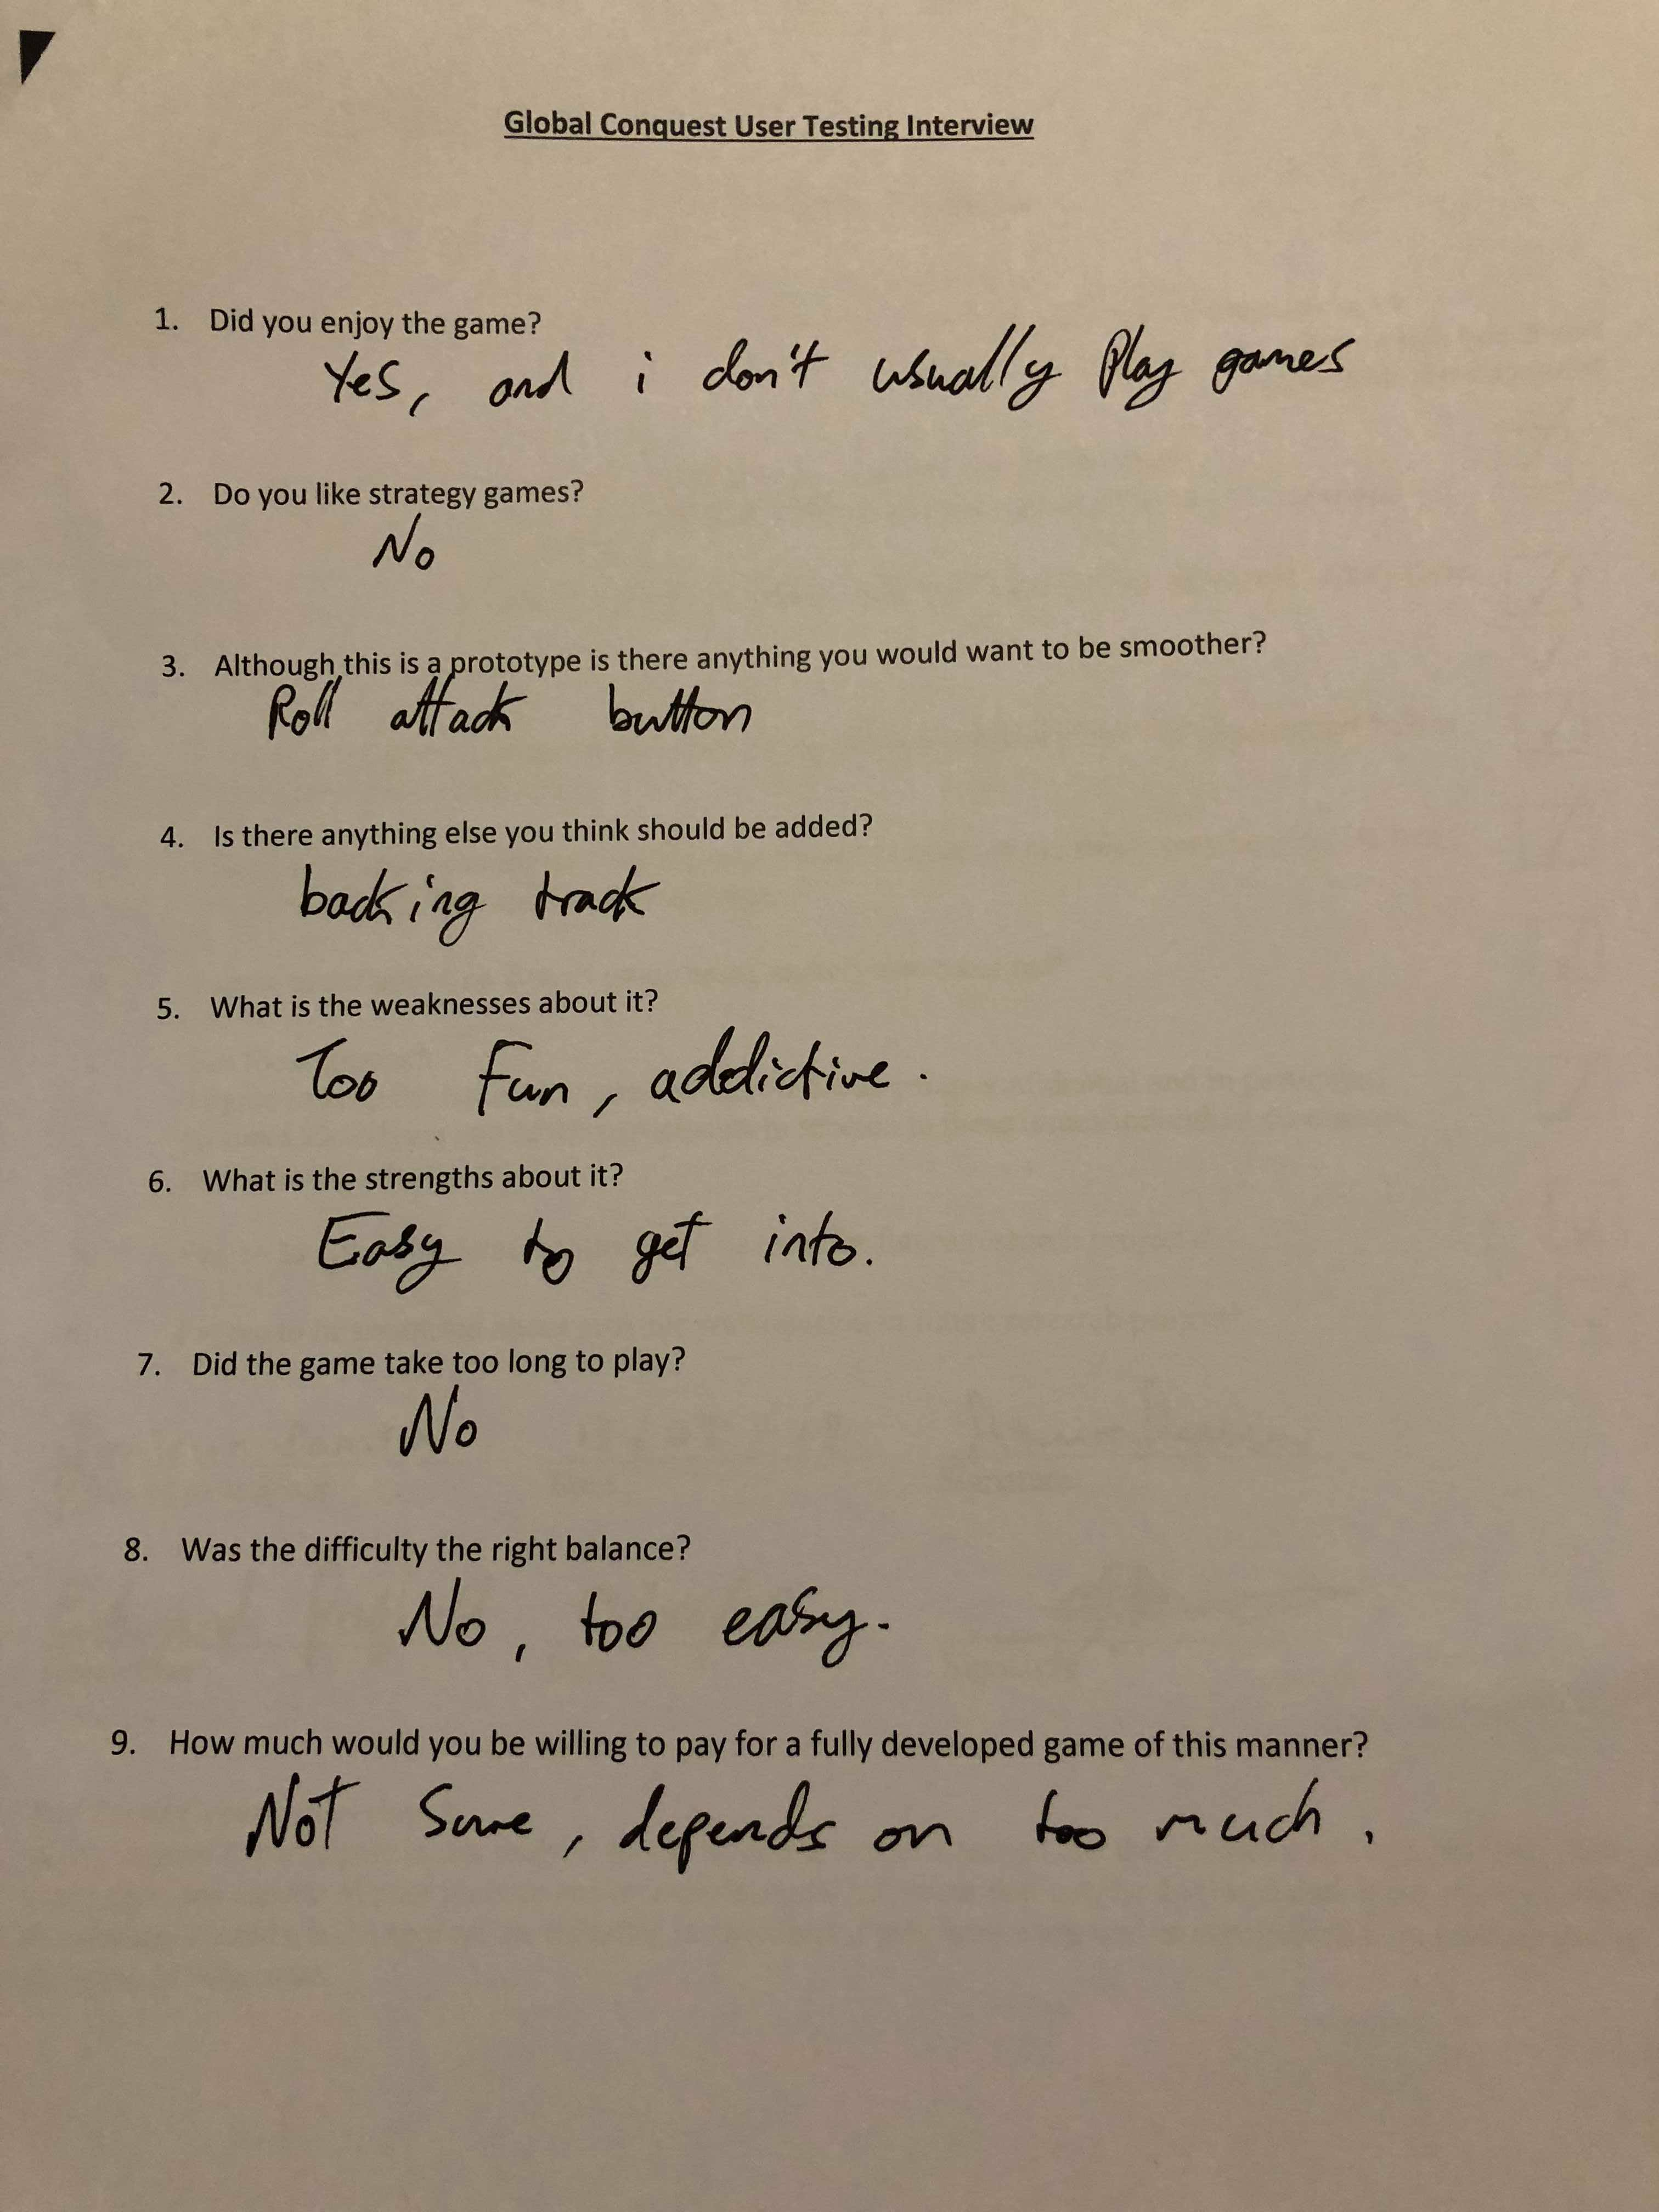

Figure 20 gives a great feedback about audio, a backing track this could consist of sound clips for when you attack or end a phase, little hints to help usability. Also the roll attack button is sometimes slow this was a limitation of Processing as nothing would make it more responsive.

## 6.4 Product Evaluation

Global Conquest meets all but two of the initial requirements, having agent heuristics so there are easy/medium/hard modes and having an artificial intelligent agent to play against. Figures ()-() prove this, with testing all of the technical aspect systematically and then getting opinions from possible users which agree with the statement that all but two initial requirements were met. The rest of the requirements are about simplistic gameplay, getting the prototype up and running. A task which in general has been completed as user/agent attacks and allocations work, there are limits, rewards and a win or a loss is calculated.

## 6.5 Introspection

One of the few mistakes made during the development process of Global Conquest was the implementation of agent attacks, system states should have been developed from earlier on to allow for an agent to base its attack depending on the state. The ability to understand the maths behind the AI was a hindrance towards developing in, this would have taken a long time to comprehend all aspects of which would of slowed down the implementation massively. In contrast the majority of Global Conquest was in working order within a relatively short time span, a lot of work done efficiently and all within the skill range of the developer a large amount of programming meant that good practice such as OOP had to be tightly kept to.

# 7.0 Discussion

The end of the methodology led to a point of uncertainty with what approach should be taken towards a more autonomous independent enemy for a user to compete against. A fork in the road, one of two paths was to be taken, either an intelligent agent through heuristics or to train an artificial intelligence to learn how to play. After managing to gather information through the use of test cases and interviews that have given insight into what people think should be done, in accordance with the type of game Global Conquest is to help with the decision. The major difference between the two is that the intelligent agent would be given heuristics to follow, which is most likely to be developed through system states and choosing the largest benefit at each. Whereas the artificially trained agent would be able to play and learn for itself through the training process of deep reinforcement learning developing its own way of strategy, possibly becoming more intelligent than a human expert. This discussion will be breaking down the two techniques by explaining them fully; and the difference between the two whilst deliberating how and why they would be applicable to Global Conquest, a study into an artificially intelligent approach. The expectations of this would be that AI would be harder to implement and longer lasting. Whereas the heuristically intelligent agent might be more appropriate for this level of game because of its easier implementation and simpler execution. There has been a huge advancement in the field of AI in the last 5-10 years, it has been attracting rapid interest in the artificial intelligence community (Reinforcement Learning: A Survey, 2018). The interest in this area is shown at a competitive level as well with, OpenAI a team backed by Elon Musk which developed an artificial intelligence which beat arguably the world’s best player at the MOBA Dota 2, Dendi. The AI took two weeks to get to a position where it had mastered the nuances that take human players years to master and is adept at tasks like zoning (stopping the enemy from getting experience and gold) and faking attacks. Although its actions aren’t any more frequent that that of player made of flesh, its choices made it triumphant (Fingas, 2018). This proves just how far AI is coming even just in computer games; however they are a perfect use for developing a system that may be applicable to the real world without nearly as many as the risks.

An intelligent agent based on heuristics, this very simply put would be to make a plan of actions that perform in different scenarios to satisfy a goal (LØLAND, 2018). The heuristics are the rules that the agent follow to arrive at an action, these can be as simple as if statements. There is however a usual complexity when it comes to the selection process of what actions to end up on; it is very common for search trees to be used. This does however lead us to what a search tree would be looking for, in most cases search trees in this context would be looking for possible benefits and would attempt to weigh them against each other; depending on more finely tuned heuristics. After all of the actions a rule generated have been executed, an evaluation method is then called. The evaluation method then has to query the environment at the time of decision to make sure the goals are going to be closer to completion (LØLAND, 2018). The design at the moment is based around predefined scripted actions, almost all if statements that simply point the agent into doing something random which sticks within the boundaries of the rules. The agent if it was to be imple-mented in Global Conquest would follow very similar rule structure as shown in figure 21.

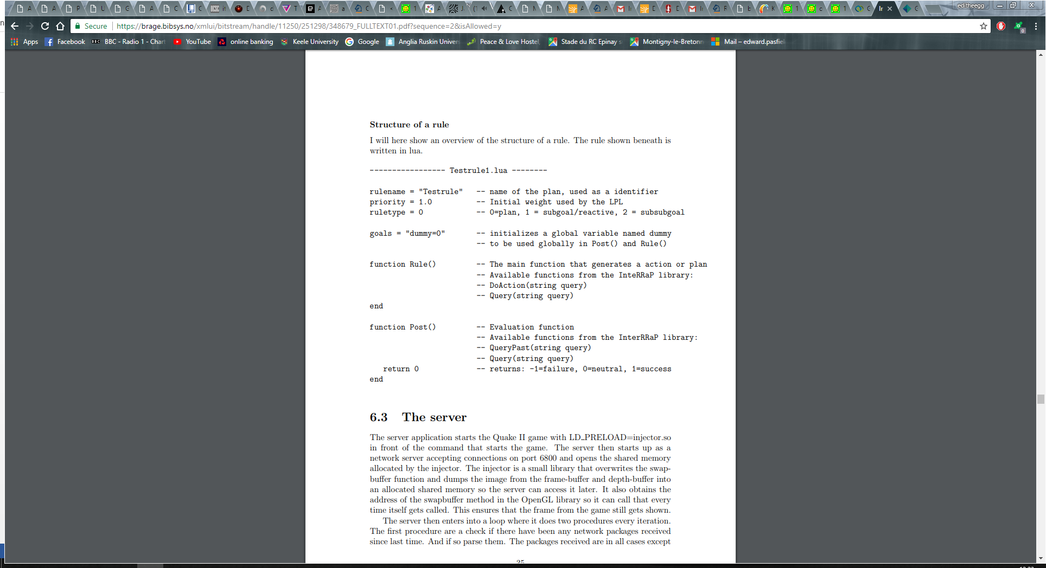

*Figure 21.*

To correctly implement this into Global Conquest the global variable used as a goal would have to be owning all the territories. The function Rule() would be where the heuristics such as; is the rule if a benefit of the attack is positive towards troop numbers in terms of ratios in the territories and the troop bonus in the territory being attacked is higher than any other options then execute action. A clearly defined rule that uses logic to detect if an aggressive action is a positive one and whether to follow through with it.

The artificial intelligence approach to the agent is less work and possibly much more effective if understood and implemented correctly. Firstly, a greedy heuristic iterative algorithm would need be developed as to solve the problems of a zero-sum game (Neural-network-based Zero-sum game for discrete-time nonlinear systems via iterative adaptive dynamic programming algorithm, 2018). This would be simpler than the previous option of a heuristic intelligent agent as it wouldn’t be as smart it would merely pick the first obvious best option.

The AI would be using deep reinforcement learning which incorporates both reinforcement learning (RL) and deep learning (DL). Reinforcement learning is about allowing an agent to learn an optimal policy through trial and error bases on its interactions with the environment being incorporated as experience to accommodate for decision making (Li, 2018). This in cooperation with deep learning which allows a computational model composed of multiple hidden layers to learn representations of data using many levels of abstraction (LeCun, 2018). Deep learning in the past has increased the effectiveness of object/speech recognition. The deep network of hidden layers influences the training pattern to work its way through finding the most beneficial routes (combinations of actions) at each state. To contextualise a possible combination of actions in Global conquest would be dragging troops before and after an internal attack. The combination of DL and RL has been the compared to AI as a whole and an equation was formed AI = DL + RL (Silver, 2018).

The main things needed to implement this into Global Conquest would be system states, agent actions and scalar reinforcement signals. A system state is to allow for the AI to be told where it is, giving it a point of reference for learning processes. A state is defined by Silver as “the presentation of a summary of experience which in turn is a sequence of observations, actions and rewards”. The agent actions are in essence the possibilities once at a state, so a combination of external drag attacks or internal attacks. An effective depiction of how the agent, environment, state and rewards all complement and work with each other is provided in a presentation given by Patrick Emami shown in figure 22.

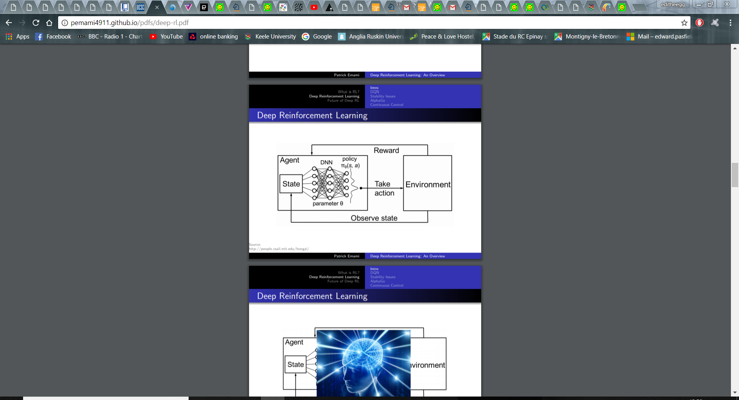

*Figure 22.*

After an action has been chosen the agent is then informed of the reward (calculated by the scalar reinforcement signals) and the subsequent state. The information regarding which action would have been most beneficial is not incorporated as this induces the agent to accumulate experience about the possibilities the system states can get into, along with corresponding actions and rewards; the main theory behind the difference of actual artificial intelligence. Figure 23 below (Reinforcement Learning: A Survey, 2018), is a very well worded explanation of this as it clearly identifies the possible states followed by the action and the following reward and state in a similar context of Global Conquest. A deep reinforcement learning network can also incorporate value functions which inform the system of predictions of future rewards, the ideology which breeds strategy.

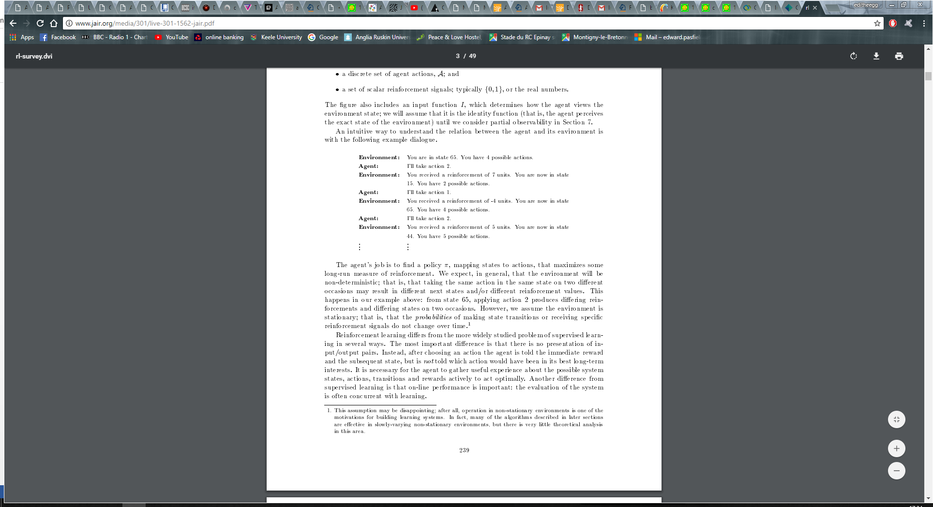

*Figure 23.*

There are some inherit differences between these two techniques but the end result isn’t too different, the advantages and disadvantages of both are clearly separated in a table below in figure 24.

|  |  |  |
| --- | --- | --- |
| **Agent Development Technique** | **Advantages**  *Figure 24.* | **Disadvantages** |
| Heuristic Intelligent Agent | 1. Easy to understand how to implement. 2. Not dynamic, so wont overcome changes. 3. Won’t look ahead for a strategy. | 1. Time consuming implementation. 2. Won’t be as intelligent and therefor maybe not as competitive. 3. Users can learn how to play against a set of rules. |
| Deep Reinforcement Learning Agent | These only occur if there is easy to use source code for the language.   1. Quick implementation. 2. More dynamic, can overcome many changes. 3. Less time consuming to implement. 4. Will use a value function to look ahead for benefits (aka form a strategy). 5. More engaging for the user to play against. | 1. Harder to understand and therefor maintain.   If there is no source code available.   1. More costly to implement. 2. Easy to break. |

To conclude even though the DRL would have been useful due to its experience based learning and its incorporation of strategic thinking through the use of value functions what this primarily comes down to is the availability of pre made source code that can be implemented within Processing. There are open source AI’s out there for Processing however for things like pong and other games/situations which are nothing like Global Conquest, even though these give useful insight into how AI would work within Processing it isn’t enough to make it worth implementing.

The heuristic based agent is just more appropriate for this level of game, it is easier to implement even though it might take longer based on the developers knowledge and wouldn’t need changing much to be able to set three different levels of difficulty, a suggestion made in figure 15, a very useful and engaging feature to add to Global Conquest. There is however a third option, which although would take the most amount of time, would cover all bases. This option would be to implement both, seeming as DRL would be using a basic heuristic agent so that it can gather information to begin with it might be worth developing that first and then making the agent have three different levels of difficulty, easy, medium and hard. The hard mode being the implementation of deep reinforcement learning. This would mean that two of the aims and objectives that weren’t met would be, ‘two birds with one stone’. The costs of this would be more but the game would benefit greatly from it.

8.0 Conclusion – How does this work contribute to the wider field.

The majority of the aims and objectives were completed, all of which led to a prototype that was fully working and allowed people to play. However not all of them were completed, the few that weren’t are 4, 5 and 7. Objective 4 is to make the agent intelligent, adaptive and competitive. The interviews in figure 17 and others, suggest it is competitive however it isn’t adaptive, this is because it will do that same thing in any situation, randomly select attacks. Half of this was completed, a reason why it should have been two different objectives. It should have been split into make the agent intelligent and adaptive, and make the agent competitive. Aim 5 was to carry out interviews to get feedback for requirements elicitation, this was not technically achieved the interviews were used in a slightly different context instead of gathering the requirements they were used to refine the prototype. Even though this did allow for new requirements to be gathered, that is not the primary use of the interviews just a happy coincidence. What should have happened to achieve this objective is a pre-development interview for Global Conquest which would have given information from possible users about what they wanted the game to be, rather than what the developer wanted. Objective 7 was to train an artificially intelligent agent to play through the use of deep reinforcement learning. The time boundaries of this were harsh, source code couldn’t be found so to come up with brand new code for this would be hard and take a long time for one person to develop especially. The conclusion that was drawn from this was that the intelligent heuristic agent was more appropriate for a simpler game as rules were easier to follow, and although technically there would be more code to apply it would be simpler. Even in contrast to this the possibility came about for doing both but this only becomes a possibility after the creation of the heuristically intelligent agent as it would be used to assist in the creation of the AI agent.

There was a selection of ideas for future developments in Global Conquest most of which came through the feedback from objective 5. The best few of these suggestions were animations, move prompts and new troop types (cavalry or ships). Animations is a simple idea to implement especially using Processing because of its visual arts context, this would have given a better visual representation of troops and attacks if proficiently applied. In turn making the user more interested and given them more satisfaction when taking out the agent’s reinforcements. Move prompts is another idea which programmatically would be deemed easy, a use of delays to print an appropriate message to the screen notifying the user of 1. The phase they are in, and 2. What attacks/territories they can attack/allocate troops to. The future development which would cause a significantly higher complexity within the program, this would mainly be because a new object ‘Troop’ would have to be created, an idea taken into account when encapsulating the code originally (mentioned in 1.1). The Troop object would be defined and would have different strengths and different rights such as ships may have the right to be in the sea and attack territories, whereas cavalry will most likely be a stronger troop that could have the right to go through a continent to attack; a complicated set of requirements for these troops would have to be defined. To implement this future design possibility with the agent either being a heuristically based agent or designed with a DRL would need to be taken into account. This is because if the heuristically based agent was used then a lot of extra code would need to be used to implement all the different possibilities. Whereas the DRL would likely overcome these new troop possibilities with ease as it would learn how to use them to its benefit.

There was a small language barrier when dealing with Processing due to it being so simplistic, this made it hard to use queues and more advanced data types. It also did not allow recognition of images, an implementation of highlighting the territory border when the mouse was over one was attempted but failed because of this.

This report analyses the steps taken towards creating a simplistic zero-sum game, such as an app, and approaches this with the idea of an intelligent agent to play against. The prototyping methodology mixed with Processing to create Global Conquest will attract a group of people who are interested in creating any program using prototyping and Java to complement each other. The discussion between deep reinforcement learning(DRL) and heuristic based intelligent agents is also a very interesting and current problem that many would find useful to compare the ways in which a developer would go about implementing and why.

# 9.0 Appendices

## 9.1 Appendix A – User Guide

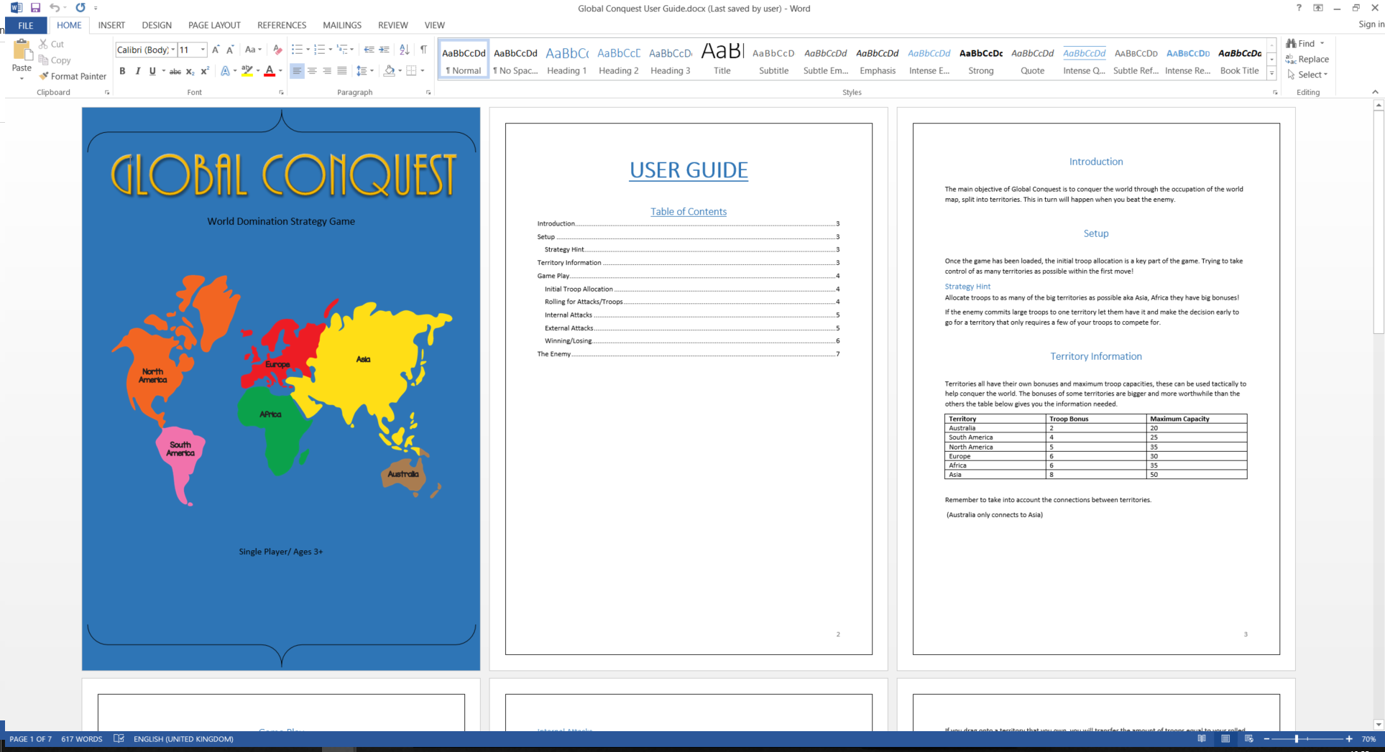

**USER GUIDE**

Table of Contents

Introduction 3

Setup 3

Strategy Hint 3

Territory Information 3

Game Play 4

Initial Troop Allocation 4

Rolling for Attacks/Troops 4

Internal Attacks 5

External Attacks 5

Winning/Losing 6

The Enemy 7

# Introduction

The main objective of Global Conquest is to conquer the world through the occupation of the world map, split into territories. This in turn will happen when you beat the enemy.

# Setup

Once the game has been loaded, the initial troop allocation is a key part of the game. Trying to take control of as many territories as possible within the first move!

## Strategy Hint

Allocate troops to as many of the big territories as possible aka Asia, Africa they have big bonuses!

If the enemy commits large troops to one territory let them have it and make the decision early to go for a territory that only requires a few of your troops to compete for.

# Territory Information

Territories all have their own bonuses and maximum troop capacities, these can be used tactically to help conquer the world. The bonuses of some territories are bigger and more worthwhile than the others the table below gives you the information needed.

|  |  |  |
| --- | --- | --- |
| **Territory** | **Troop Bonus** | **Maximum Capacity** |
| Australia | 2 | 20 |
| South America | 4 | 25 |
| North America | 5 | 35 |
| Europe | 6 | 30 |
| Africa | 6 | 35 |
| Asia | 8 | 50 |

Remember to take into account the connections between territories.

(Australia only connects to Asia)

# Game Play

## Initial Troop Allocation

Once you have loaded the game up, the start screen should look like this.

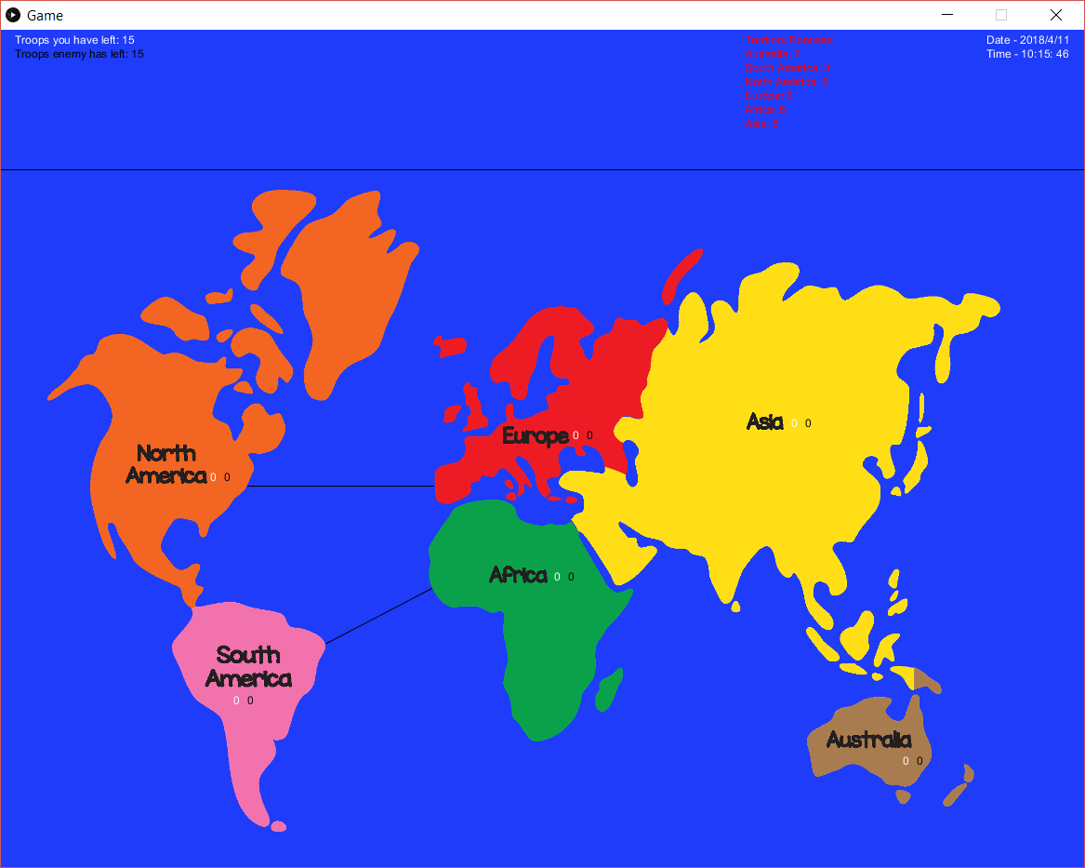

You will have 15 troops to allocate where you wish. Click on a territory to allocate a troop there. Do so wisely.

## Rolling for Attacks/Troops

Once you have run out of troops to allocate in the initial stage, a box will appear in the centre of the screen.

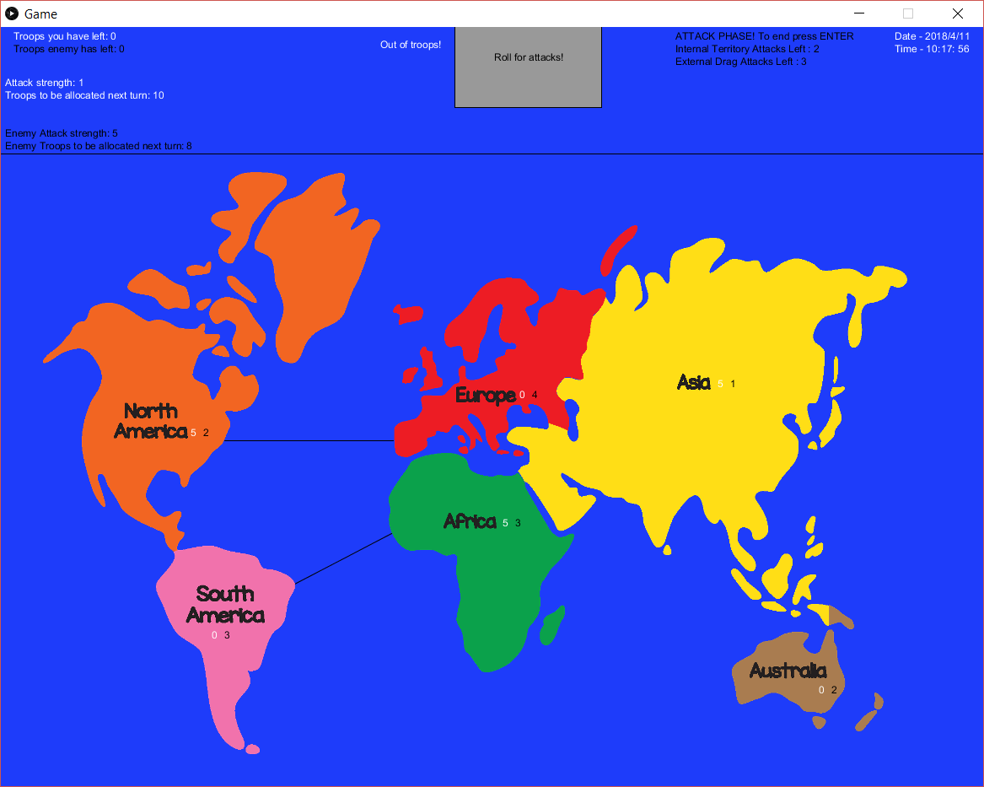

Click this to randomly roll your attack strength (1-6), and your troop reserves for next turn (1-12)



## Internal Attacks

When performing an internal attack, click on a territory with both user troops and enemy troops in it. This will reduce both armies by the attack number you rolled when rolling for attacks.

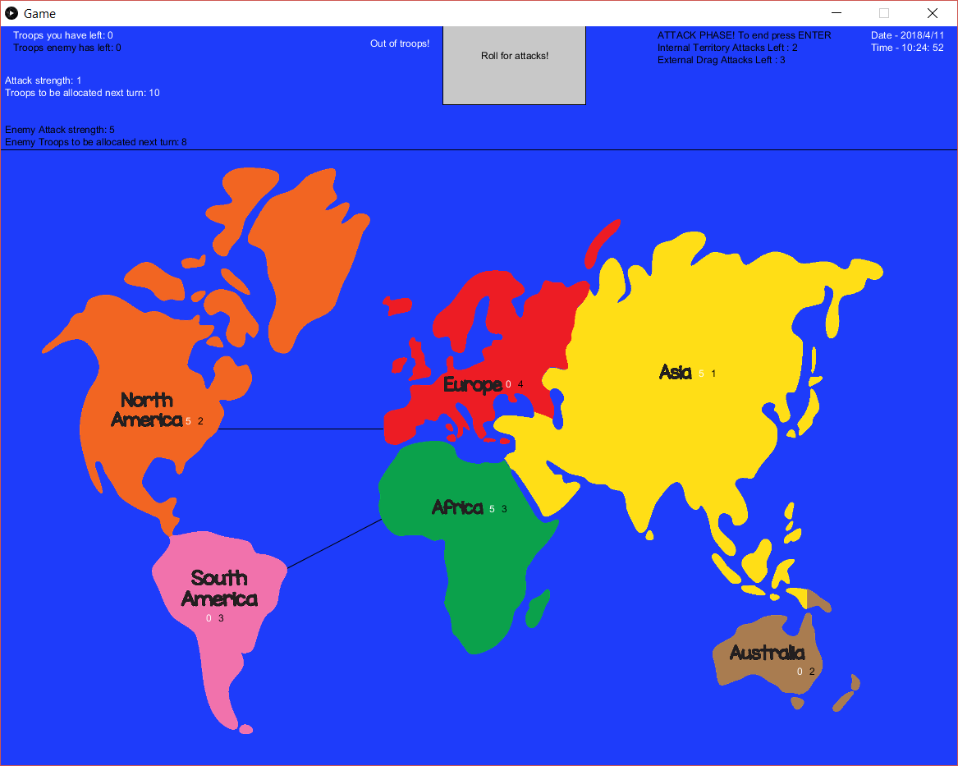 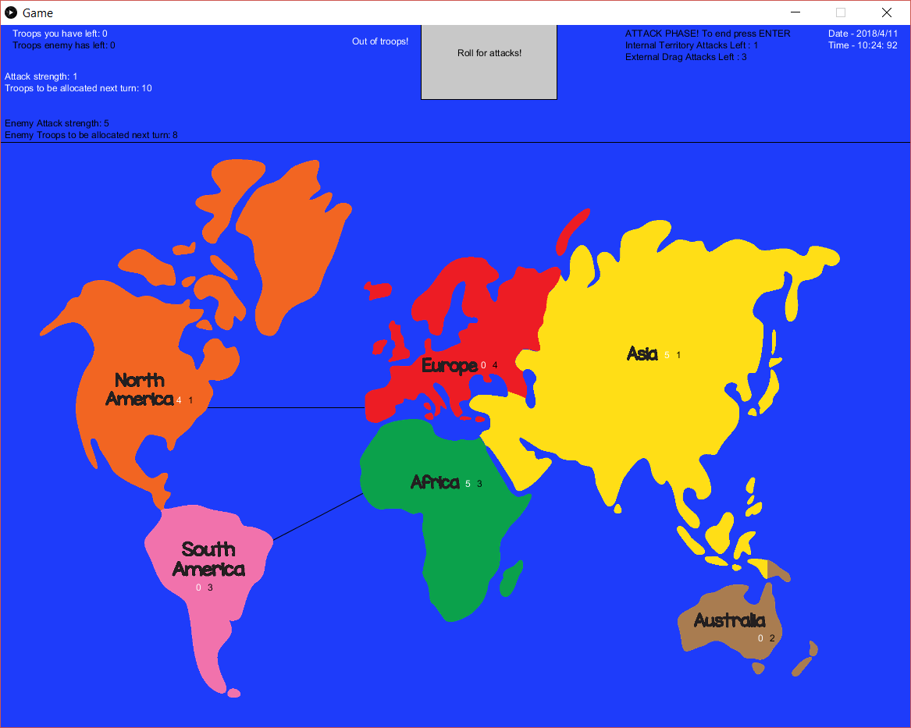 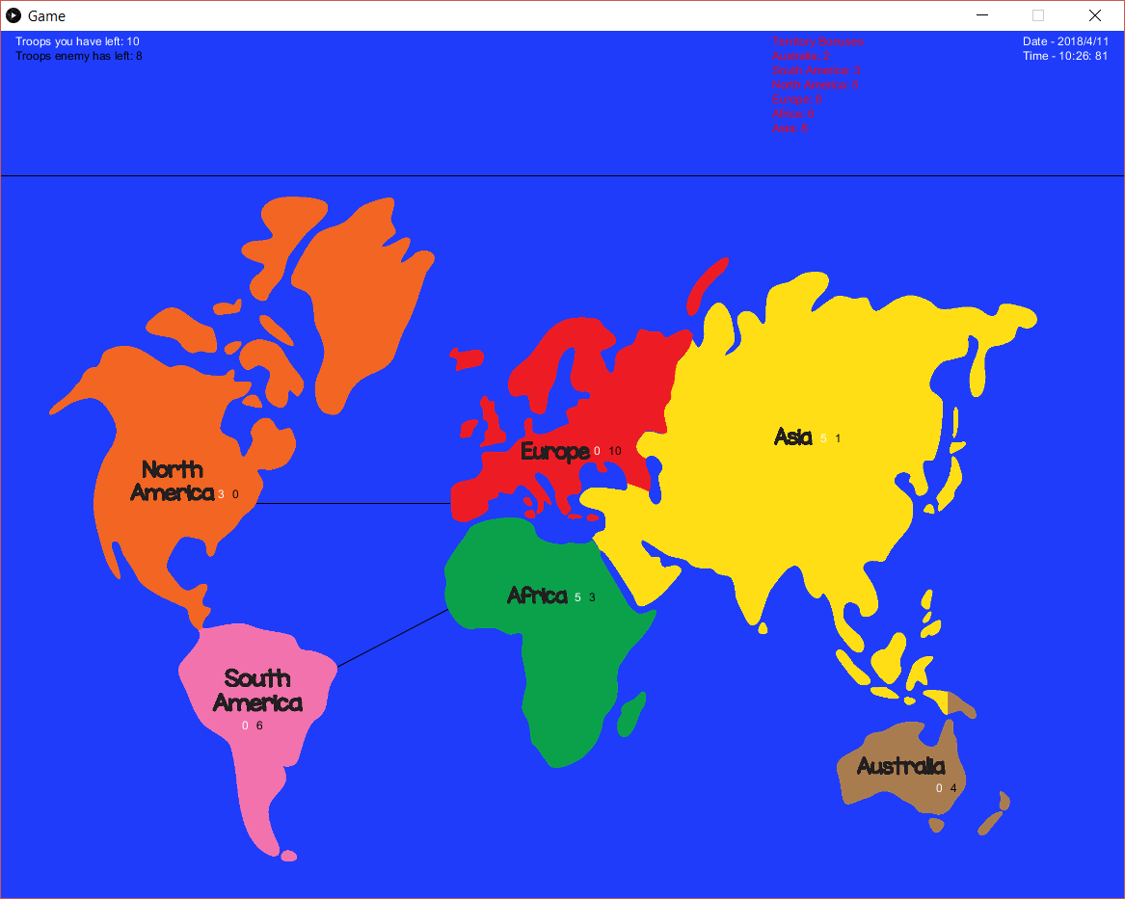

Until either your troops, the enemy troops, or the internal attack count hits 0.

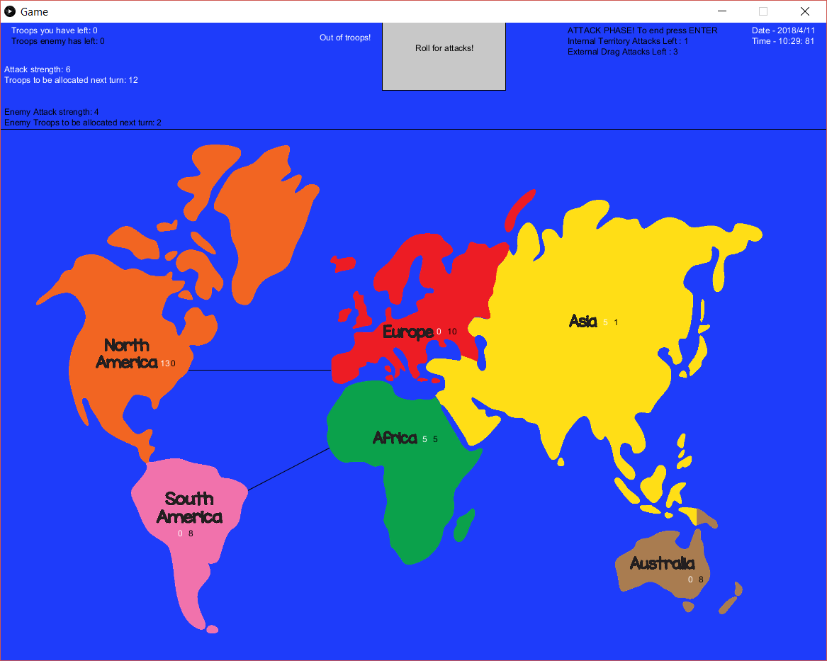

## External Attacks

Also known as drag attacks, allow you to attack territories that are next to ones you own! You must click on a territory you have troops on and the enemy has no troops on and drag it onto another territory.

If you drag onto a territory with enemy troops on it will reduce the amount of your troops and the enemy troops by your previously rolled attack strength.

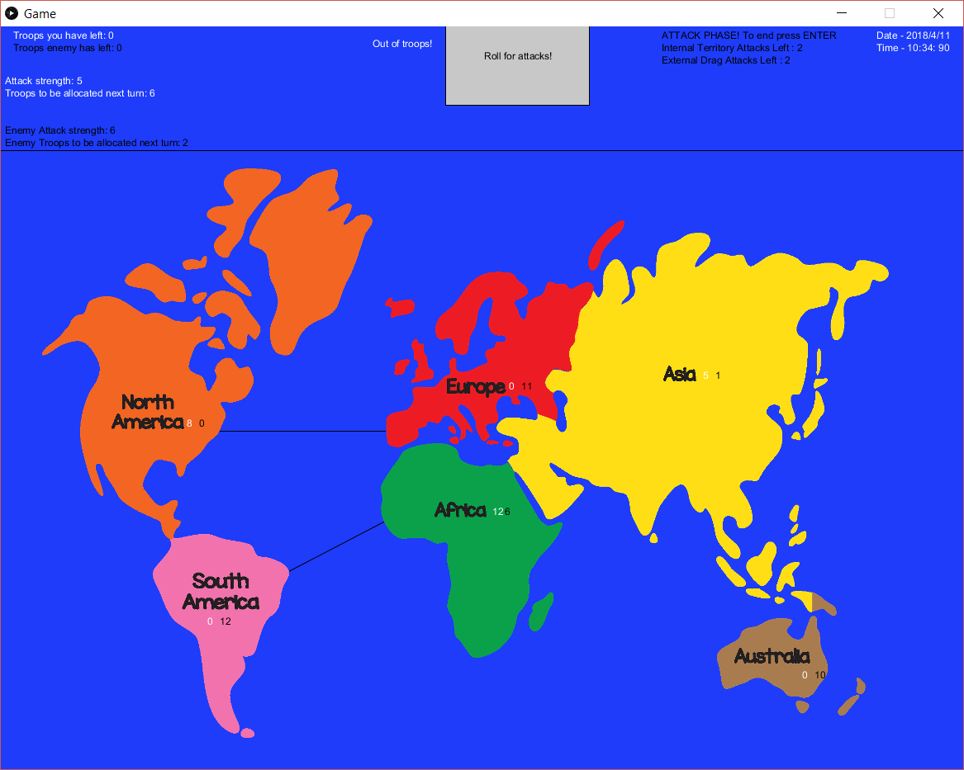 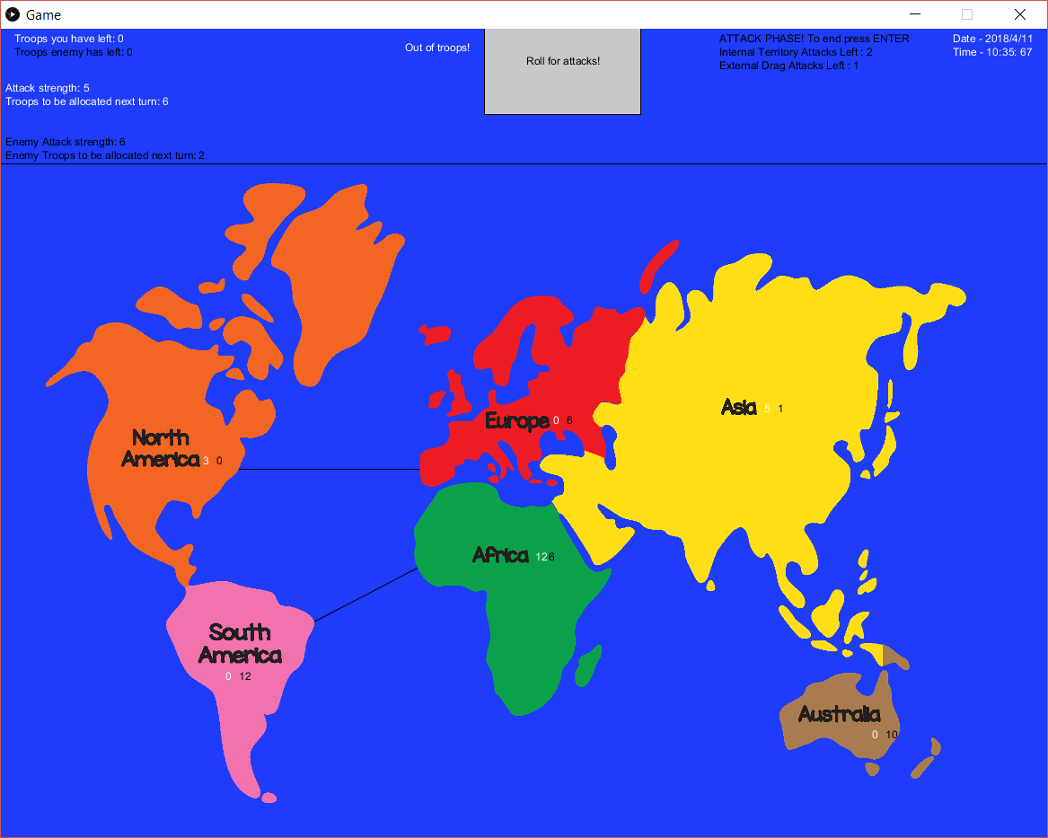

If you drag onto a territory that you own, you will transfer the amount of troops equal to your rolled attack strength to the new territory. A way of moving your armies around the map.

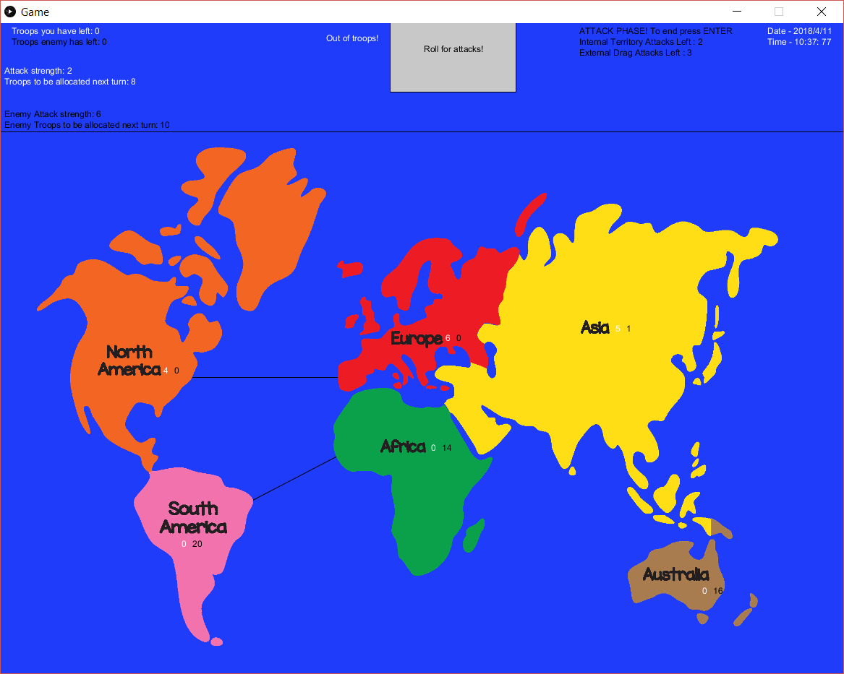

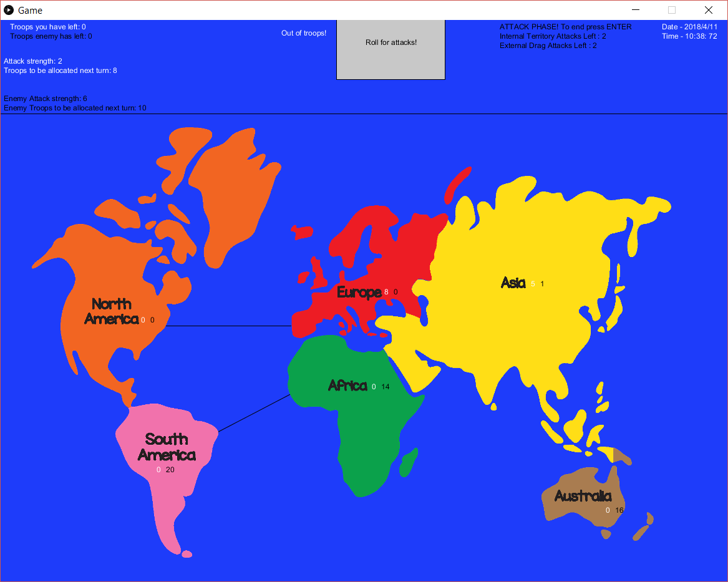

Be careful when doing this as it may leave you vulnerable!

## Winning/Losing

1. Winning - Own all territories, have troops in all 6 territories while the enemy has none in any of them. Total Domination.
2. Losing - All territories are owned by enemy, you have no troops on the map.

* Round counter runs out. 30 turns have passed, time loss.

# The Enemy

The enemy will get the same amount of troops for initial allocation, and will be rolled random attacks/troop reserves for themselves. The enemy will also get the same territory bonuses you would, so don’t let them get a head start. The difference is there attacks will be more random making them harder to predict and will randomly reduce territories when you use external attacks; so use them wisely.

## 9.2 Appendix B – Global Conquest Code



## 9.3 Interviews

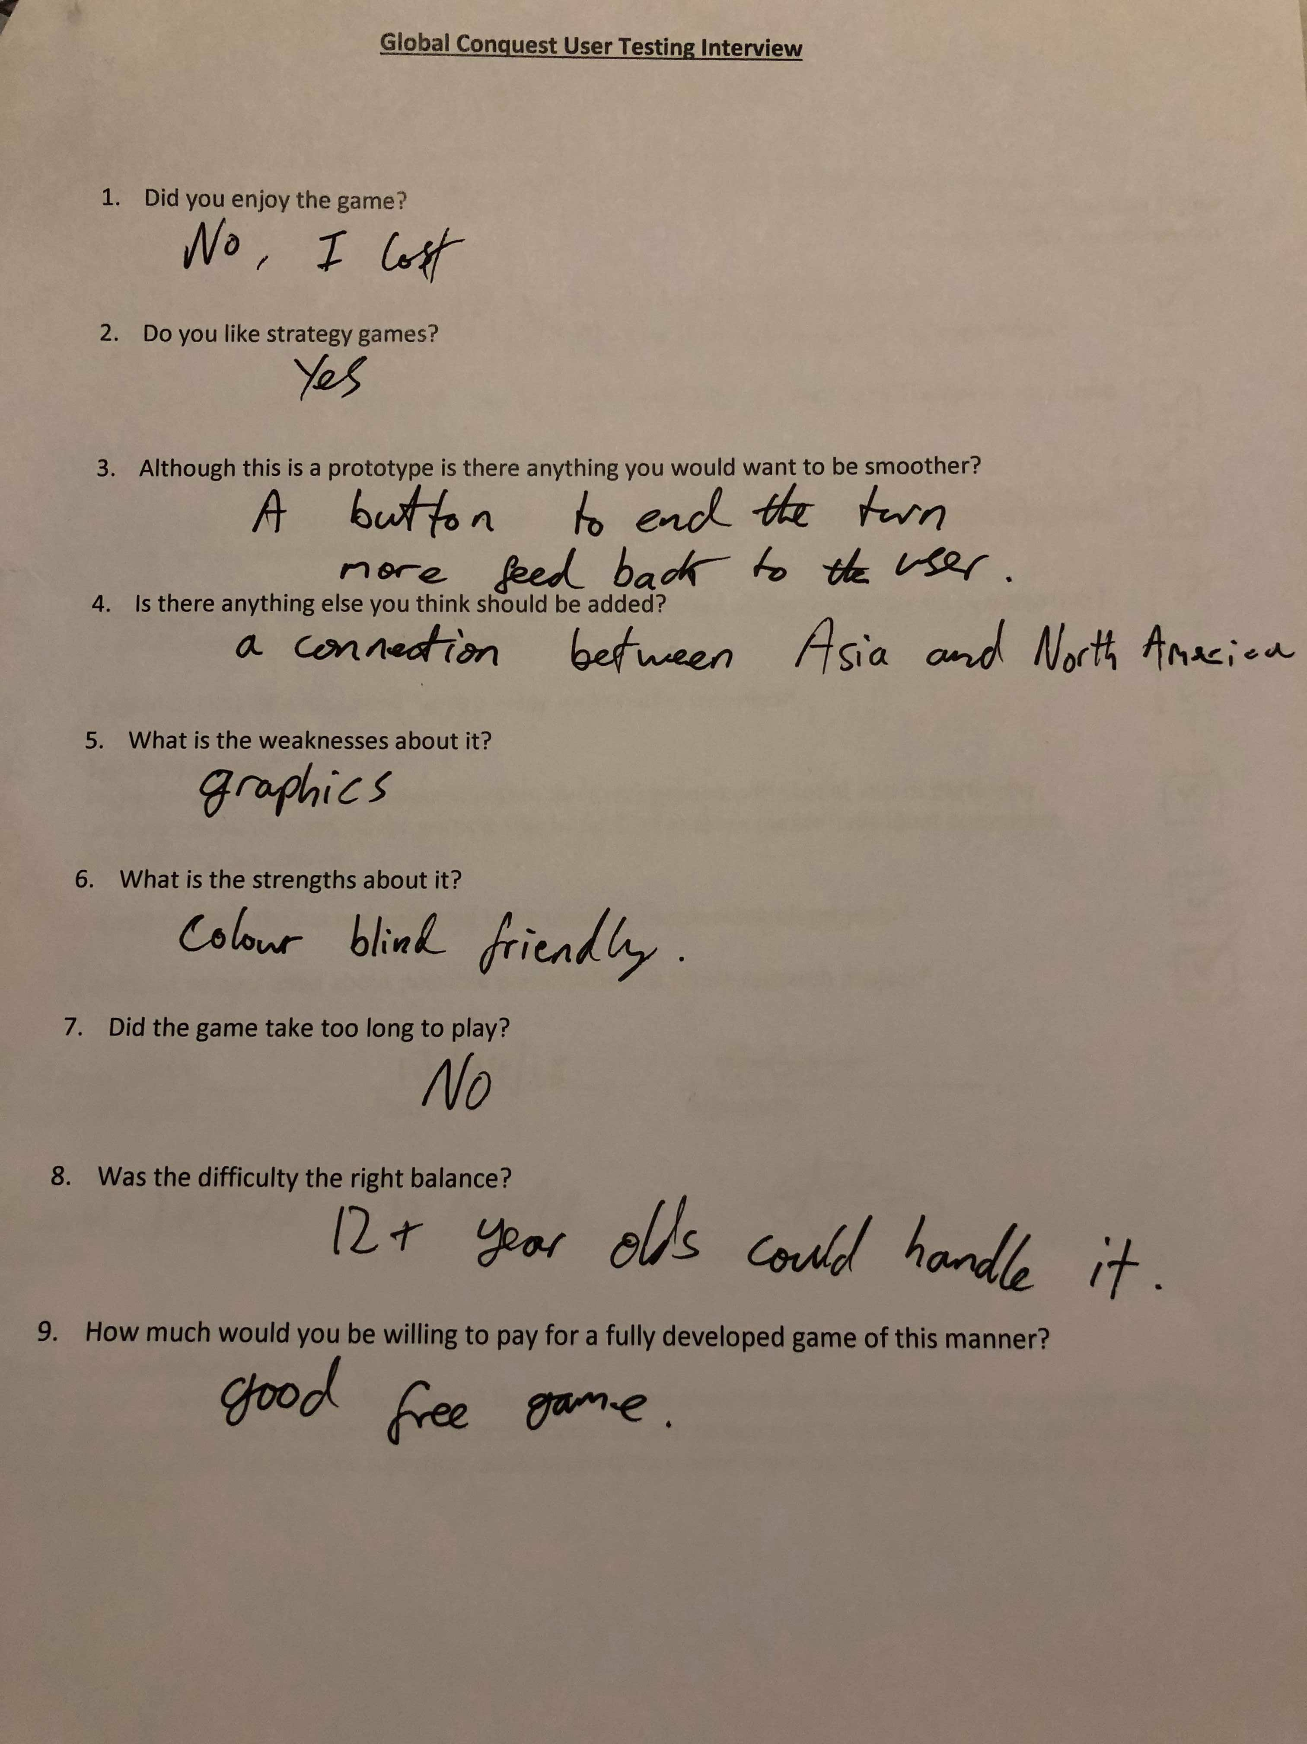

# C:\Users\Edward\AppData\Local\Microsoft\Windows\INetCache\Content.Word\Interview4MatildaBarca.jpg

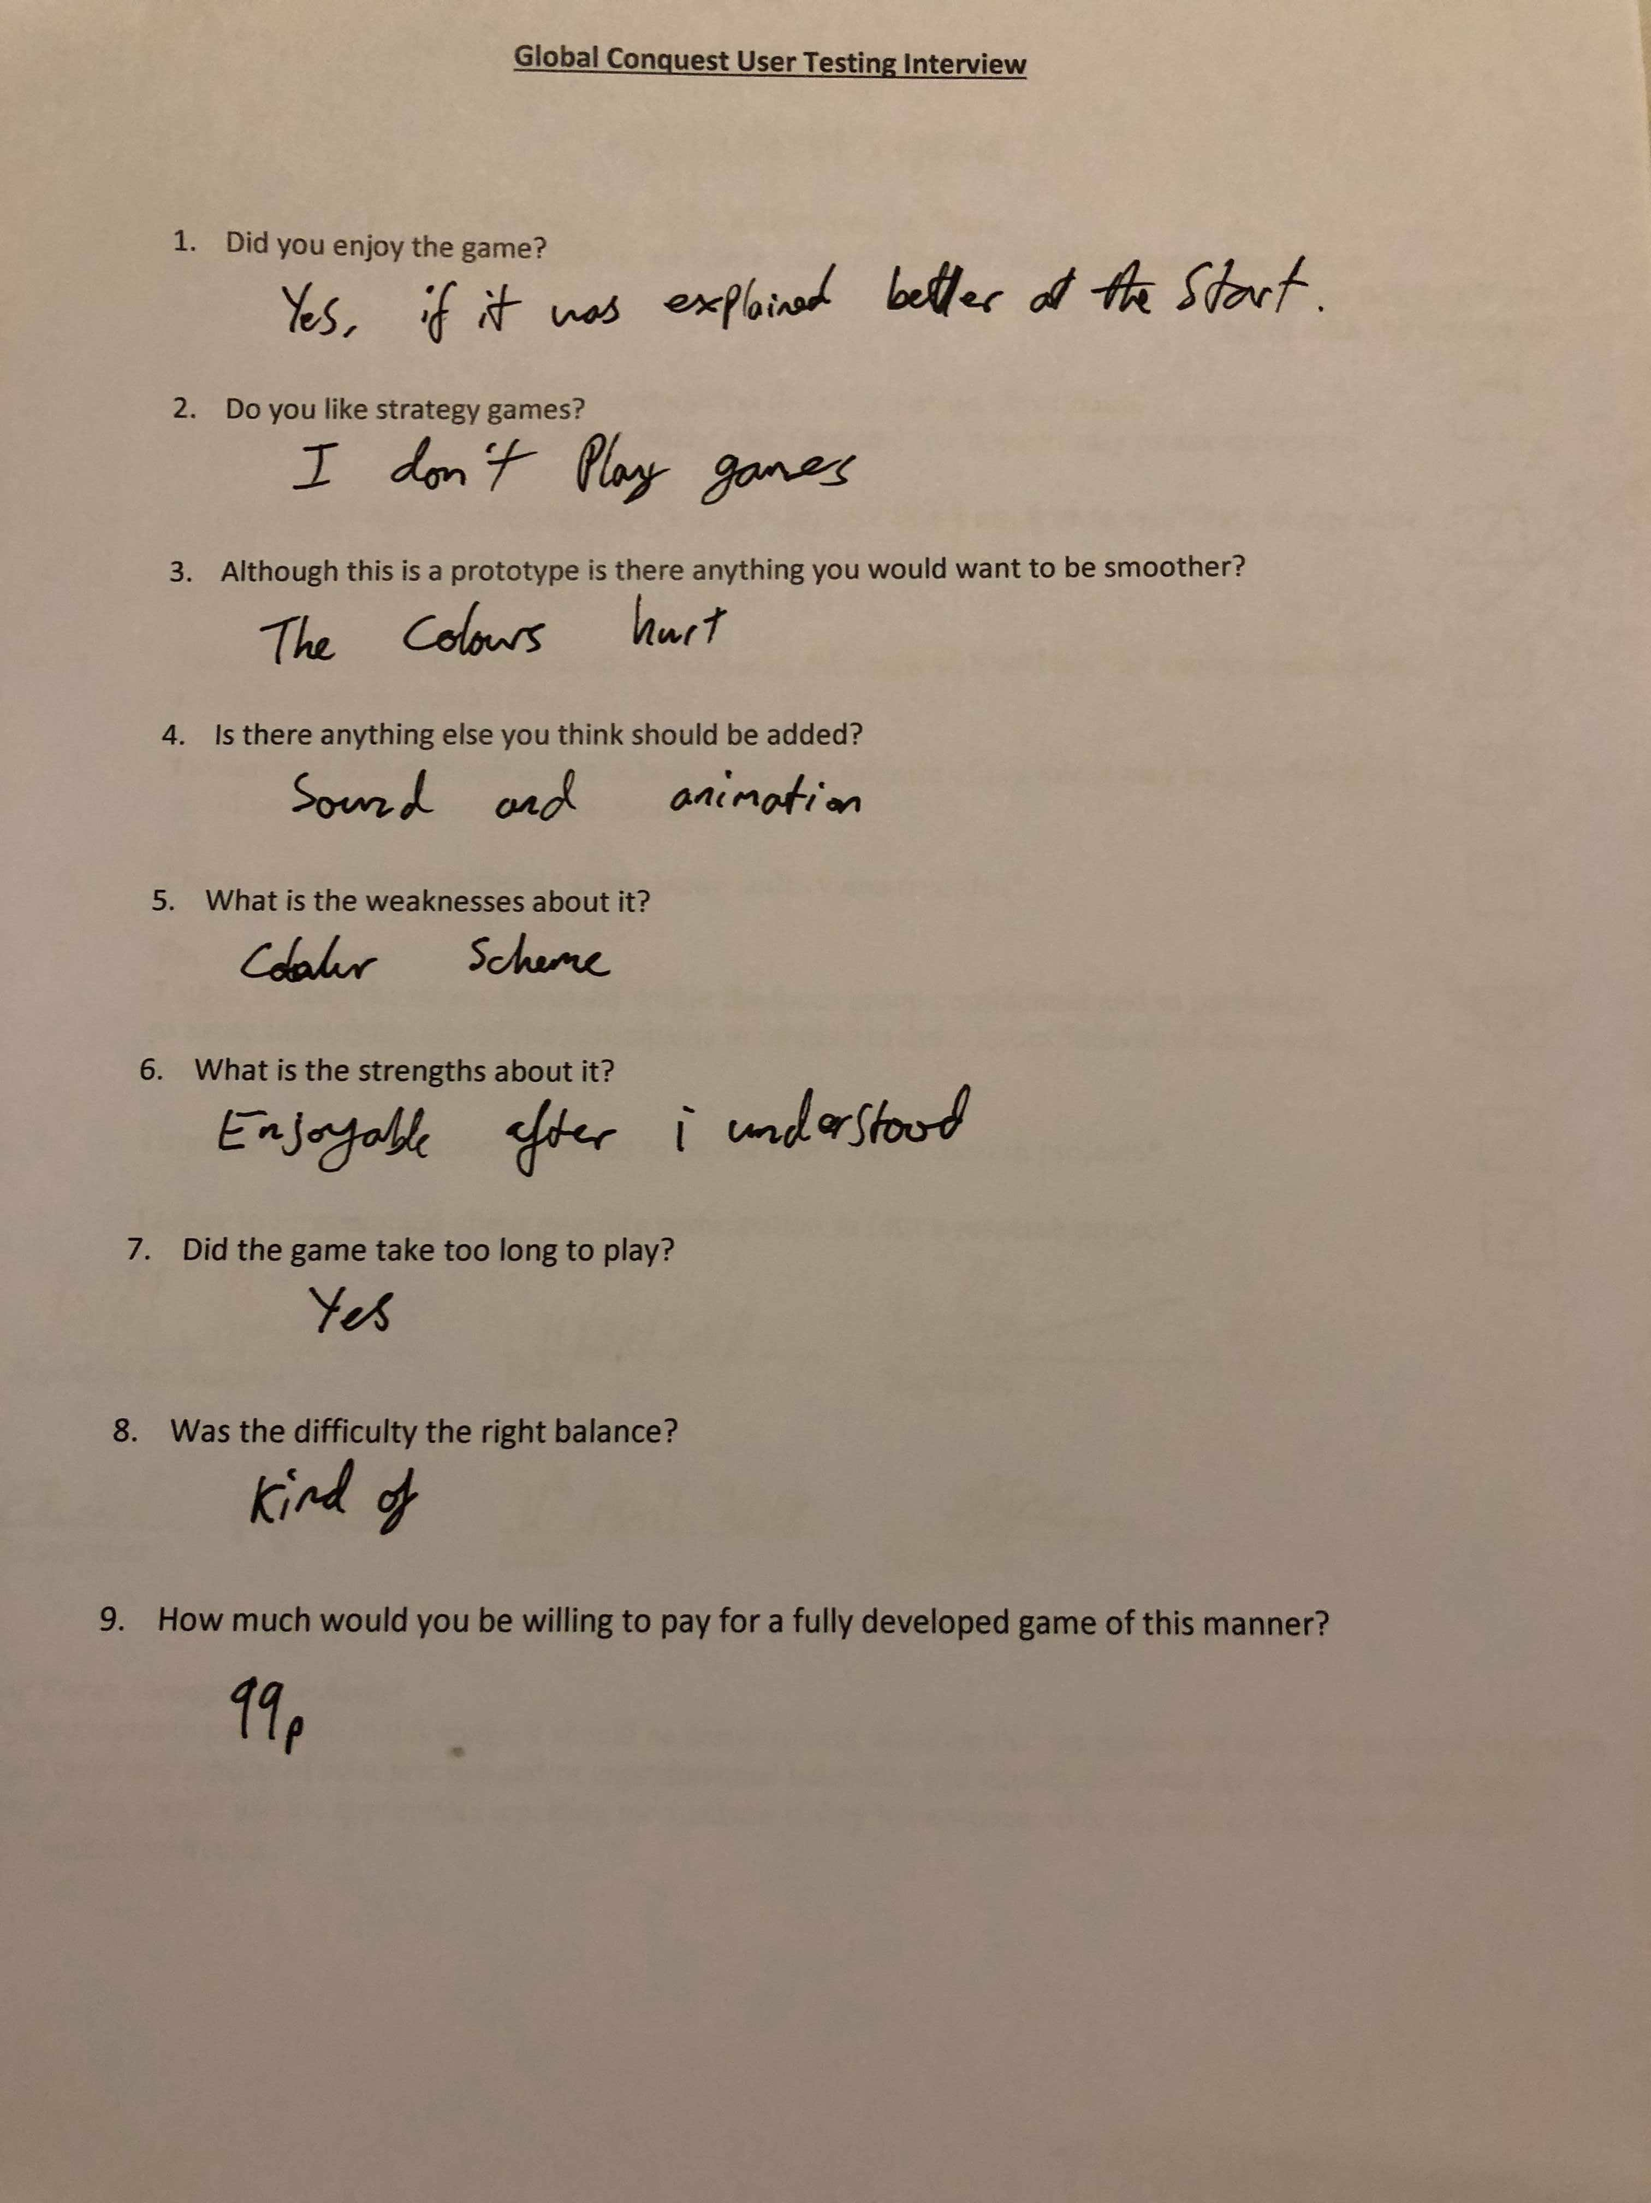



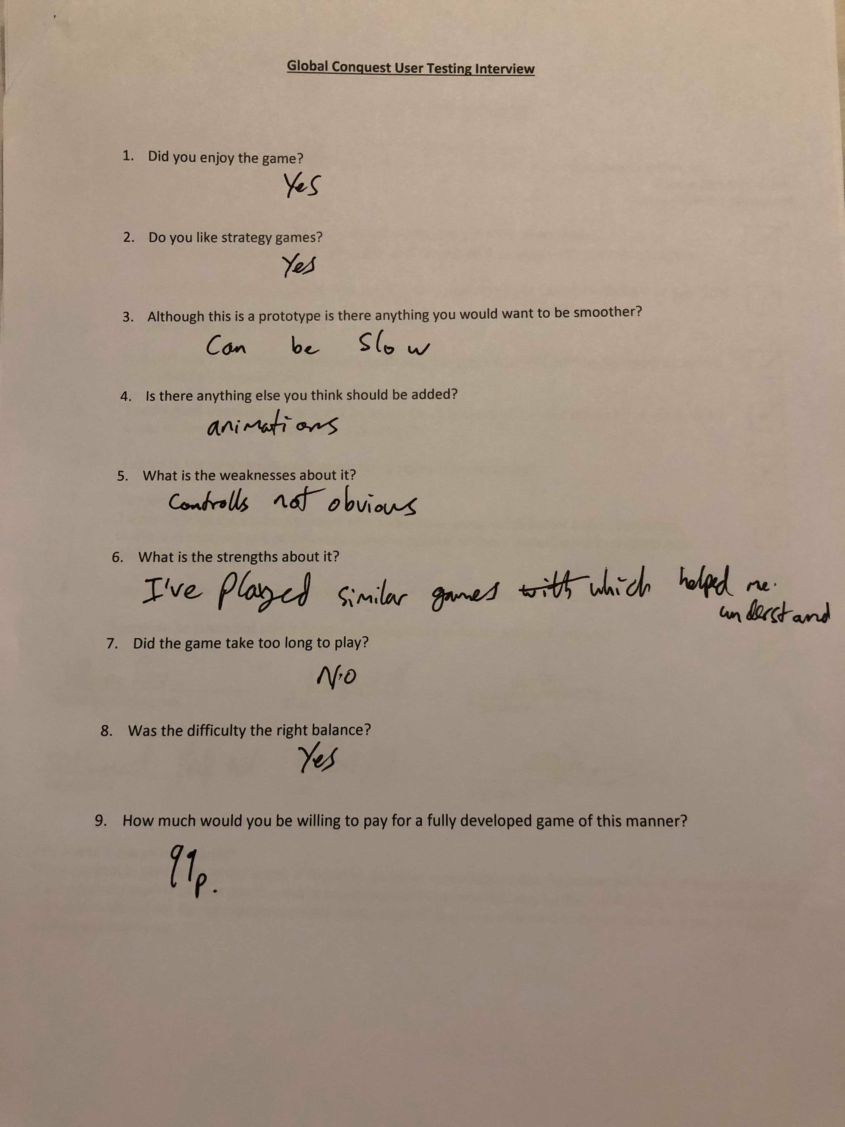

# 10.0 Bibliography

Agent Technologoy. (2018). [ebook] Berlin, pp.3-28. Available at: <https://link.springer.com/chapter/10.1007/978-3-662-03678-5_1> [Accessed 12 Apr. 2018].

Anon, (2018). [online] Available at: <http://istqbexamcertification.com/what-is-prototype-model-advantages-disadvantages-and-when-to-use-it/> [Accessed 4Feb. 2018]

Anon, (2018). Should games have a fixed difficulty mode?. [online] Available at: <https://www.gamespot.com/forums/system-wars-314259282/should-games-have-a-fixed-difficulty-mode-33362793/> [Accessed 15 Apr. 2018]

Burgen, K. (2013) Game design theory: a new philosophy for understanding games. (CRC Press, US)

Cs.cmu.edu. (2018). Agent Intelligence. [online] Available at: <http://www.cs.cmu.edu/~lanthony/classes/SEng/Design/heuristic.html> [Accessed 7 Apr. 2018]

Deep Learning NN. (2018). [image] Available at: <https://www.quora.com/What-is-the-difference-between-Neural-Networks-and-Deep-Learning> [Accessed 13 Apr. 2018].

Fidas, C. (2018). Requirements Elicitation for new Video Game Development Tools: A Case Study. [ebook] pp 1-3. Available at: <http://hci.ece.upatras.gr/files/c201_Fidas_Avouris_Orvieto_Interact_2015.pdf> [Accessed 10 Apr. 2018]

Fingas, J. (2018). AI beats top ‘Dota 2’ players in one-on-one matches. *Engadget.* [online] Available at: <https://www.engadget.com/2017/08/12/ai-beats-top-dota-2-players/> [Accessed 15 Apr. 2018].

LeCun, Y. (2018). Deep Learning. [ebook] Available at: <https://www.nature.com/articles/nature14539> [Accessed 15 Apr. 2018].

Li, Y. (2018). Deep Reinforcement Learning: An Overview. [ebook] Available at: <https://arxiv.org/pdf/1701.07274.pdf> [Accessed 14 Apr. 2018].

LØLAND, K. (2018). Intelligent Agents in Computer Games. [ebook] Norwegian University of Science and Technology. Available at: <https://brage.bibsys.no/xmlui/bitstream/handle/11250/251298/348679_FULLTEXT01.pdf?sequence=2&isAllowed=y> [Accessed 14 Apr. 2018]

Masters, M. (2018). An Overview of Requirements Elicitation > Business Analyst Community & Resources | Modern Analyst. [online] Mondernanalyst.com. Available at: <http://www.modernanalyst.com/Resources/Articles/tabid/115/ID/1427/An-Overview-of-Requirements-Elicitation.aspx> [Accessed 10 Apr. 2018].

Mnih, V. (2018). *Playing Atari with Deep Reinforcement Learning.* [ebook] Available at: <https://arxiv.org/pdf/1312.5602.pdf> [Accessed 11 Apr. 2018].

Neural-network-based Zero-sum game for discrete-time nonlinear systems via iteratie adaptive dynamic programming algorithm. (2018). [ebook] Institue of Automation, Chinese Academy of Sciences, Beijing 100190, PR China. Available at: <https://www.sciencedirect.com/science/article/pii/S0925231213000076> [Accessed 14 Apr. 2018]

Ozcan, E. (2018). *A Simple Intelligent Agent for Playing abalone Game: ABLA.* [pdf] Istanbul: Yeditepe University. Available at: <https://pdfs.semanticscholar.org/91d2/51c2532316fc1f70c146c022a2cb5c3ab0cc.pdf> [Accessed 11. Apr. 2018]

Pasfield, E. (2018). An AI Approach to a World Domination Game.

Processing.org. (2018). Processing.org. [online] Available at: <https://processing.org/> [Accessed 8 Apr. 2018].

Prototyping Model. (2018). [image] Available at: <http://istqbexamcertification.com/what-is-prototype-model-advantages-disadvantages-and-when-to-use-it/> [Accessed 4 Feb. 2018].

Reinforcement Learning: A Survey. (2018). [ebook] Brown University. Available at: <http://www.jair.org/media/301/live-301-1562-jair.pdf> [Accessed 14 Apr. 2018]

Silver, D. (2016). Deep reinforcement learning, a tutorial at ICML 2016. http://icml.cc/ 2016/tutorials/deep_rl_tutorial.pdf.

Space Invaders Atari 2600. (2018). [image] Available at: <https://www.giantbomb.com/space-invaders/3030-5099/> [Accessed 13 Apr. 2018]

Stefik, M. (2018). Object Oriented Programming: Themes and Variations. [ebook] p.41. Available at: <https://www.aaai.org/ojs/index.php/aimmagazine/article/view/508/444> [Accessed 10 Apr. 2018].

World Map – Continents. (2018). [image] Available at: <https://www.giftofcuriosity.com/product/montessori-world-map-and-continents-printables/> [Accessed 6 Jan. 2018].